Report on the assessment of biological responses to suspended sediments in the deep ocean in support of environmental threshold development

A report prepared for the Intersessional Expert Group on Turbidity and settling of resuspended sediments

Jesse van der Grient
Daniel Jones
Malcolm Clark

February 2025

Contents
1. Background 2
2. Introduction 2
3. Methods 3
3.1 Measuring sediment plumes 3
3.2 Data selection 3
3.3 Statistical analyses 4
4. Results 7
4.1 Nature of responses - qualitative responses observed in the literature review 7
4.2 Quantitative data description 10
4.3 Mixed-effect models 11
4.4. Dose-response curves 13
5. Conclusions 20
5.1 Summary of key findings 20
5.2 Mining scenarios 21
6. Uncertainties, gaps and limitations 22
6.1 Sample sizes 22
6.2 Sediment type, sharpness and size 22
6.3 Life stage effects 23
6.4 Response choice 23
6.6 Experimental design 23
6.7 Geographical locations and natural background sediment concentrations 23
6.8 Future research 24
7. Suggestions 24
7.1 Suggestions regarding the use of threshold values 24
8. Acknowledgements 25
9. References 25

1. Background
The International Seabed Authority (ISA) has the responsibility for the regulation and control of mining-related activities across the Area and ensuring the effective protection of the marine environment from harmful effects related to mining activities, mandated under the 1982 United Nations Convention on the Law of the Sea (UNCLOS) and the 1994 Agreement relating to the implementation of Part XI of UNCLOS. Currently, the ISA is developing the rules, regulations and procedures for the exploitation of mineral resources in the Area.
The exploitation of the seabed for mineral resources has the potential for causing environmental impacts at the seafloor and in the water column, including via the creation of sediment plumes that will increase turbidity in the environment. Further, when plumes settle this too can cause harmful effects via burial. Sediment plumes can be expected at the seafloor and water layer just above the seafloor, specifically the benthic boundary layer. Plumes are created by the movement of mining vehicles and recovery of mineral resources (collector plumes) and in the water column when recovered sediments are discharged from support vessels (discharge or dewatering plumes).
During the 27th Part II Session of the ISA Council, a proposal was submitted on the development of binding environmental threshold values (ISBA/27/C/30), upon which the Council took the decision to progress this development (ISBA/27/C/42). It was decided to focus initially on the development of environmental thresholds for three main pressures: a) Toxicity, b) Turbidity and settling of resuspended sediments, and c) underwater noise and light pollution. The development of these thresholds is led by the Legal and Technical Commission and supported by scientific and technical expertise of an intersessional expert group (IEG), with a subgroup for each main pressure. The work undertaken for this report was requested by the subgroup on Turbidity and settling of resuspended sediments, following some initial analyses discussed by the subgroup in November 2024. The outcome of this study will support further discussions by the IEG.

2. Introduction
Increasing suspended sediment concentrations in aquatic environments is known to cause harmful effects (Bryce et al., 2010; Chapman et al., 2014; Donohue and Garcia Molinos, 2009; Erftemeijer et al., 2012; Fabricius, 2005; Kemp et al., 2011; Kjelland et al., 2015; Newcombe and Jensen, 1996; van der Grient and Drazen, 2022; Wenger et al., 2017; Wilber and Clarke, 2001). These effects can be classified in (non-mutually exclusive) feeding, behavioural, growth, respiratory, physiological, reproductive, and survival responses, with various specific examples in each category. Predominately, this information has come from shallow-water environments, and many responses are shared between different sites and habitats (see supplementary table S4 in van der Grient & Drazen (2022)). It is likely that many of these responses will also occur with deep-sea animals in response to sediment plumes. While a recent peer-reviewed article concluded that insufficient empirical studies were available to determine specific responses for deep-sea animals (van der Grient and Drazen, 2022), since then the number of publications have increased, making it worthwhile to investigate further deep-sea specific responses and sensitivities to suspended sediment concentrations.
This report investigates the effect of suspended sediment concentrations on deep-sea animals, with the main aim of providing a dose-response relationship for sediment concentrations and affected animals (%) to support discussions regarding the level of protection of the marine environment under potential mining scenarios. The higher-level objectives of the IEG into which this study feeds are: (i) synthesize and review existing literature on thresholds, (ii) identify appropriate indicators to define threshold metrics, (iii) define threshold levels, including early warning thresholds, and (iv) evaluate critical gaps in knowledge related to threshold determination and recommend future required work.
This report is organised as follows: Section 3 describes the methods and data used to determine whether deep-sea animals respond to suspended sediments and how, and the development of dose-response relationships for deep-sea animals and suspended sediments. Section 4 describes the results of the analyses, including the synthesis of what has been studied and where, factors influencing the strength of responses to suspended sediments, dose-response relationships, including a general version and others that take into consideration factors that could influence sensitivities. Section 5 gives a summary of key findings, and a discussion of how sensitivities may vary, and how the dose-response relationship compares to mining plumes (based on the current best available data). Section 6 outlines uncertainties, gaps and limitations in the dataset and analyses. Section 7 outlines suggestions for the use of the results presented.

3. Methods

3.1 Measuring sediment plumes
Turbidity can be measured by volumetric (e.g., mg/l) or light scattering units (e.g., Nephelometric Turbidity Units, NTU). These two measures are only directly comparable between each other if they have been calibrated in controlled (laboratory) settings. In addition, while volumetric units between different studies are comparable, this is not the case for studies using the scattering of light to measure turbidity. While the amount of sediment added to the water is known in volumetric measures, light can be scattered differently by many different kinds of particles present in the water (e.g., sediment particles, dissolved minerals, organic matter, etc. (Bilotta and Brazier, 2008)). This can result in situations where similar sediment concentrations in different samples of water have different light scattering values. This introduces more uncertainty around the measurement of responses to suspended sediments which cannot easily be accounted for in statistical analyses (van der Grient and Drazen, 2022). The volumetric method is the most common in experimental studies focusing on the responses of animals to suspended sediment.

3.2 Data selection
A search for studies relating to deep-sea animal responses to suspended sediments was conducted. Deep-sea animal studies were identified as studies focusing on animals that can occur in water depths >200 m. A database of peer-reviewed literature focusing on animal responses to suspended sediments (van der Grient and Drazen, 2022) was used as a starting point, where studies focusing on deep-sea animals were selected (n = 8). A search on Google scholar using the search terms “deep sea” and “sediment*” or “plume*” resulted in several additional studies, and through searches in the reference lists in these studies, additional primary literature was identified (n = 17). Data from a further unpublished study (NIWA, unpublished data) was provided for this project (n = 1). The sources were further analysed to determine whether their information met certain criteria. Studies were included in the final database when (i) they reported on both control and treatment (sediment exposure) responses, (ii) their control treatments had no sediment added to the water supply, (iii) reported the number of replicates, (iv) reported a variability measure (standard error or standard deviation), (v) used volumetric methods, and (vi) investigated responses to suspended sediments. The data selection was not constrained to a particular duration nor direction (e.g., positive, negative) of the responses. It was noted that some individual animals were collected shallower than 200 m. These studies were still included if the species are normally considered deep-sea animals and were occurring shallower either because of diurnal vertical migration (whereby animals move to shallower waters in the night), or because in the collection areas the presence of cold water allows deep-sea animals to occur shallower.
Few studies have been conducted on deep-sea animals, largely because of the challenges involving capturing, retrieving and maintaining deep-sea animals alive for controlled experiments. As a result, experiments focusing on drill-cutting, mine tailings and natural sediments (used in studies that either investigated resuspension effects of bottom-trawling or deep-sea mining) were combined, but note that therefore several different types of sediments were used in the experiments. In cases where information was unclear or missing, authors were contacted with the request for further detail. The design of these experiments could include continuous exposures or pulsed exposures. Some studies explicitly mentioned that sediments were treated to remove organics, while other studies did not. Acclimation periods prior to the start of experiments were generally reported in the studies. The length of studies varied, from a few hours to several months. To maximise the data coverage, these studies were all included for the investigation of further analyses.
The final database of studies included 15 peer-reviewed articles and the NIWA dataset (16 studies), detailing 350 responses (more detail on these responses is given in Section 4). Studies focused almost exclusively on adult responses. The studied species focused predominately on corals (Anthozoa) and sponges (Demospongiae), while three groups (Bivalvia, Scyphozoa, and Hexactinellida sponges) were the focus of only one study each. No experiments were found on other taxonomic groups or that met the criteria for the data selection. Various biological responses were reported, including feeding, growth, physiological, respiratory, and survival responses (Appendix A). The mean for control and treatments (sediment concentration), experimental duration, taxon, life stage, and sampling location were extracted from the studies (Appendix A). Data were either extracted from tables directly or from graphical images using WebPlotDigitizer v4.2 (Rohatgi, 2019).

3.3 Statistical analyses
Two different types of analyses were carried out. In the first analysis, mixed effect models were used to determine whether, in general, deep-sea animals respond in a positive, negative or neutral way to increased suspended sediments, and if certain factors influence these responses. All taxa were used in these analyses. In the second analysis, dose-response relationships were established using only those sediment concentrations that elicited significant animal responses. These latter analyses were constrained to benthic Cnidaria and Porifera given the data availability for these groups. The analyses conducted here followed the framework laid out in van der Grient & Drazen (2022).
3.3.1 Mixed-effect models
To investigate deep-sea animal responses across studies and response types (e.g., respiration, survival), responses were first standardised. The natural log-transformed response ratio (LnRR) (Hedges et al., 1999; Lajeunesse, 2011) was used for this effort as this transformation places metrics on a similar scale and unit and thereby allows for comparison across studies and responses. This transformation does require values to be larger than 0 and selecting those data where average values were larger than 0 reduced the sample size from 350 to 325. Data were then further transformed when necessary to ensure consistency in response direction (e.g., mortality LnRR values were multiplied by -1 to create consistency with survival values). See Appendix A for the calculated LnRR values.
Mixed-effect models were created to investigate whether there is an overall type of response (positive, negative, neutral) to suspended sediments in deep-sea animals. Mixed-effect models consist of fixed effects – effects that are of interest – and random effects – effects that are the result of experimental design choices but could potentially influence results. For example, different studies used different types of sediments, different species (with different types of evolutionary histories), specimens were obtained from different geographical locations, etc. Such differences could influence results and need to be accounted for in the analyses.
Two different mixed-effect models were constructed. First, a model was constructed to study the overall response of deep-sea animals to suspended sediment concentrations. This used three random factors (study, response category, taxonomic name) and one fixed factor (sediment concentration). All studies reported on multiple responses measured, and it is possible that responses (in similar response categories) coming from the same study are more similar to one another because of researcher and measurement bias than to another study. To capture the potential uncertainty introduced by the multiple responses reported by each study, we include the random factor study. The type of response measured (behaviour, growth, respiration, physiological, etc.; category) could potentially also influence effects, as certain responses (e.g., feeding) are elicited at lower sediment concentrations than others (e.g., survival). However, as it is not clear what type of response will be likely elicited by deep-sea mining plumes at what concentrations, as well as that responses will likely vary across a plume because of plume dilution. Thus, this variable was included in the model as another random effect. Responses to suspended sediment concentrations can be species specific (Kemp et al., 2011; Kjelland et al., 2015; Newcombe and Jensen, 1996; Wenger et al., 2017), but as the interest of this model is to determine whether there is a general response, taxonomic name was used as a random factor in the model, to account for potential variation coming from the use of different species. The treatment (sediment concentration) was log-10 transformed to meet model assumptions of equal variance.
A second mixed-effect model was constructed to study factors that could potentially influence relationships between responses and sediment concentrations. For example, exposure type (continuous or pulsed) could influence responses, as recovery periods could allow animals to respond differently to sediment plumes (Robinson et al., 2010). Recovery periods could give animals time to clean themselves, gather energy via food, or reduce their stress levels, which can play a role in tolerance and resilience. Sediment type is known to influence responses as the size, sharpness and mineralogy of particles could alter animal responses to suspended sediments (Bilotta and Brazier, 2008; Donohue and Irvine, 2003; Kutti et al., 2015; Robinson et al., 2010). Therefore, these two factors were included as fixed factors in this second model, and an interaction was specified between sediment concentration and exposure type. In addition, a further fixed effect was introduced, Class, to determine whether taxonomic variation at this level could explain some variation in the responses to suspended sediments. This second model therefore contained two random factors, study and response category (see reasoning above), with taxonomic name removed and replaced by the amalgamated Class fixed effect. The sediment concentration (treatment) was again log-10 transformed to meet model assumptions of equal variance.
While the exposure duration is known to have an effect on animal responses to suspended sediments (Hewitt and Norkko, 2007; Newcombe and Jensen, 1996; Robinson et al., 2010; Shaw and Richardson, 2001), this variable was not included in any of the models. To study the effect of duration, a sediment concentration needs to be tested at many different lengths of duration (e.g., from days to weeks and months). In the collated dataset used here, most sediment concentration levels were tested at only 2-3 different time points, providing insufficient information to test for the effect of duration.
The mixed-effect models were optimised following the protocol outlined in Zuur et al. (2009). The models were checked for model assumptions of normality in residuals and equal variance. The significance of fixed effects was evaluated using ANOVA (type III) using the Satterthwaite’s method to estimate degrees of freedom, while random effects were tested using a χ² test on the difference in deviance between the full model and reduced model (where a random factor was removed). The log response ratios and mixed-effect models were analysed in R v.4.4 (R Core Team, 2024) using packages metafor (Viechtbauer, 2010), lme4 (Bates et al., 2015), lmerTest (Kuznetsova et al., 2017), and performance (Lüdecke et al., 2021). The visualisations were created using tidyverse (Wickham et al., 2019). Factors were considered significant against the threshold of $α$ = 0.05, with p values below this threshold deemed significant.
3.3.2 Dose-response relationship
Each response in each study focused on corals or sponges was evaluated against their specific control values to determine whether the sediment concentration elicited a significant response using a standard t test. If a response was significantly different from the response in the control, the sediment concentration and related information regarding species, study, sampling location, exposure type and sediment type were extracted. This resulted in 54 data points (see Appendix A for the selected data points). These sediment concentration values were used to fit a logistic cumulative probability distribution, following the method designed by Wenger et al. (2018) and applied by van der Grient & Drazen (2022). Bootstrapping procedures (n = 1000) were used to obtain 95% confidence intervals. A general dose-response relationship was created, and to explore the influence of various factors, different dose-response relationships were created using subsets of the data, but only where at least 15 data points were available for each group in the factor. The factors investigated include: (i) exposure length - acute ($≤$ 7 days of exposure) vs. chronic ($>$ 7 days of exposure; n = 31 and 23, respectively); (ii) exposure type - continuous vs. pulsed (n = 31 and 23 respectively); (iii) phylum - Cnidaria vs. Porifera (n = 29 and 25, respectively), and (iv) response category – physiology (n = 17), and survival (n = 20). Tables presenting the sediment concentrations (mean and 95% confidence intervals) at which a specific portion of individuals would be affected are presented for each dose-response relationship. Dose-response relationships were tested for differences in their distribution (acute vs. chronic, continuous vs. pulsed, Cnidaria vs. Porifera, physiology vs. survival) using the Kolmogorov-Smirnov test. This test was selected because it is known to be sensitive to any differences in distributions, based on shape, spread or median. In addition, the non-parametric Wilcoxon rank sum test was performed to determine whether there was a difference in the location of the dose-response relationships. Significance is evaluated against the threshold of $α$ = 0.05, with p values below this threshold deemed significant.

4. Results

4.1 Nature of responses - qualitative responses observed in the literature review
Many different responses were described in the deep-sea studies, and while there were examples covering most response categories, no responses were described for behaviour (other than feeding behaviour, which is included in the feeding category). For response categories that had at least one example of that type of response, often many more response examples have been observed in shallow-water environments (Table 1); note that the absences are more likely artefacts of lack of investigation rather than lack of responses in deep-sea animals.
Focusing solely on the deep-sea studies included here, several responses have been observed. Within the feeding category, responses observed in deep-sea animals included affected feeding rates via the changes in polyp behaviours (Carreiro-Silva et al., 2022; Larsson et al., 2013), changes in clearance rates (Wurz et al., 2024), and the clogging of filtering structures (Carreiro-Silva et al., 2022; Kutti et al., 2015; Larsson et al., 2013; Mobilia et al., 2023, 2021; Scanes et al., 2024; Tjensvoll et al., 2013; Wurz et al., 2024, 2021). Growth responses included responses of tissue loss (Mobilia et al., 2023), changes in bodily condition (Scanes et al., 2024; Stenvers et al., 2023), changes in energy stores in tissues (Larsson et al., 2013) and changes in growth rates (Larsson et al., 2013). Studies focusing on physiological responses often focused on biomarkers, such as the general stress marker lysosomal membrane stability (LMS) (Edge et al., 2016; Scanes et al., 2024, 2018). Other biomarkers used included enzymes that regulate the defence against reactive oxygen species (ROS) (Carreiro-Silva et al., 2022; Edge et al., 2016). Oxygen uptake can be impaired by ROS as foreign particles (xenobiotics) including sediment particles can stimulate ROS production. Several enzymes, including superoxide dismutase (SOD) and catalase (CAT), are important antioxidant enzymes in the primary defence against ROS and play a role in the immune response of aquatic organisms (Yang et al., 2017). Changes in these enzymes are also often used as indicators of stress, as the upregulation of these enzymes means increasing the defence towards ROS. Because the enzymes play different roles in the defence pathway, it is important to note that potential changes in their activity can be time sensitive and changes in their activity against time may indicate that some of the defences have become overwhelmed under oxidative stress. For example, lipid peroxidation (LPO) may be triggered when CAT becomes overwhelmed. Changes in nitrogen or silicate were also considered physiological responses as these can affect metabolism and biomineralisation which affects energy demands (Bilan et al., 2023; Carreiro-Silva et al., 2022; Scanes et al., 2024, 2018). Respiratory responses measured via respiration rates were the most studied responses (Bilan et al., 2023; Carreiro-Silva et al., 2022; Kutti et al., 2015; Larsson et al., 2013; Mobilia et al., 2023, 2021; Scanes et al., 2024, 2018; Stenvers et al., 2023; Tjensvoll et al., 2013; Wurz et al., 2024, 2021). Järnegren et al. (2017) was the only study that investigated a reproductive response by studying larvae. While the study mostly looked at survival responses in the larvae exposed to suspended sediments, it is worth noting that sediment particles were observed adhering to larvae, which can affect their swimming efficiency, and in turn could affect settlement success or efficiency. Several studies investigated the survival of animals in response to suspended sediments (Bilan et al., 2023; Brooke et al., 2009; Carreiro-Silva et al., 2022; Järnegren et al., 2017).
Table 1. Responses observed in shallow-water marine environments and the deep ocean, categorised by response type (feeding, behaviour, growth, physiology, respiration, reproduction, and survival). Bolded references are referring to deep-sea specific results. These responses may not always have been quantified but been described qualitatively. The x indicates that this response was observed.
Response type | Response | Shallow water |  |  | Deep ocean | References
Feeding | Reduced foraging rates, success, or efficiency | x |  |  | x | Carreiro-Silva et al. (2022); Larsson et al. (2013); Meager et al. (2005)
 | Predation-style switching | x |  |  |  | De Robertis et al. (2003); Helenius et al. (2013); Lunt & Smee (2015)
 | Changed clearance rates | x |  |  | x | Wurz et al. (2024); Arendt et al. (2011); Hewitt & Pilditch (2004); Kang (2012); Kiørboe et al. (1980); Riisgård et al. (2003); Robinson et al. (1984); Safi et al. (2007); Shin et al. (2002); Tokumon et al. (2015)
 | Changed pseudofaeces and rejection rates | x |  |  |  | Arendt et al. (2011); Armsworthy et al. (2001); Haven & Morales‐Alamo (1966); Kiørboe et al. (1980); Klumpp (1984); Riisgård et al. (2003); Robbins (1984); Robinson et al. (1984); Safi et al. (2007)
 | Clogging of gut, oesophagus, or filtering apparatus | x |  |  | x | Carreiro-Silva et al. (2022); Kutti et al. (2015); Larsson et al. (2013); Mobilia et al. (2021); Mobilia et al. (2023); Scanes et al. (2024); Tjensvoll et al. (2013); Wurz et al. (2021); Wurz et al. (2024); Alurralde et al. (2019); Fuentes et al. (2016); Rosenthal (1971)
 | Changes in gut residence time | x |  |  |  | Alurralde et al. (2019); Fuentes et al. (2016)
Behaviour | Reduced cover use or changed movement patterns | x |  |  |  | Hansen et al. (1991)
 | Affected escape responses | x |  |  |  | Meager et al. (2006); Meager et al. (2005)
 | Communication changes in territorial, mating or shoaling behaviour | x |  |  |  | Engström-Öst & Candolin (2007); Franklin et al. (2018); Heuschele et al. (2009); Järvenpää & Lindström (2004); Sundin et al. (2010); Wong et al. (2007)
 | Increased coughing, gill flaring or squirting, or changes in mucus production | x |  |  |  | Larsson et al. (2013); Scanes et al. (2024); Stenvers et al. (2023); Wurz et al. (2021); Armsworthy et al. (2001); Au et al. (2004); Klumpp (1984); Robbins (1984); Torre et al. (2014)
Growth | Reduction in growth rate, increase in weight loss, or reduction in energy storage | x |  |  | x | Larsson et al. (2013); Mobilia et al. (2023); Scanes et al. (2024); Stenvers et al. (2023); Bricelj et al. (1984); Cumming & Herbert (2016); Ellis et al. (2002); Torre et al. (2014); Wenger et al. (2012)
Respiration | Changes in respiration rates | x |  |  | x | Bilan et al. (2023); Carreiro-Silva et al. (2022); Kutti et al. (2015); Larsson et al. (2013); Mobilia et al. (2021); Mobilia et al. (2023); Scanes et al. (2018); Scanes et al. (2024); Stenvers et al. (2023); Tjensvoll et al. (2013); Wurz et al. (2021); Wurz et al. (2024); Bannister et al. (2012); Bell et al. (2015); Ellis et al. (2002); Lohrer et al. (2006); McGrath et al. (2017); Pineda et al. (2017); Telesnicki & Goldberg (1995); Torre et al. (2014)
Physiology | Gill structural changes | x |  |  |  | Au et al. (2004); Cumming & Herbert (2016); Hess et al. (2017); Hess et al. (2015); Wong et al. (2012)
 | Clogging of gill structures | x |  |  |  | Boehlert & Morgan (1985); Lin et al. (1992)
 | Increased stress responses | x |  |  |  | Meager et al. (2006)
 | Changes in oxidative stress responses or osmoregulation | x |  |  | x | Bilan et al. (2023); Carreiro-Silva et al. (2022); Edge et al. (2016); Scanes et al. (2018); Scanes et al. (2024); Au et al. (2004); Carrasco-Malio et al. (2014); Lin et al. (1992); Pinheiro et al. (2019); Yang et al. (2017)
 | Changed microbiome at respiratory surfaces | x |  |  | x | Stenvers et al. (2023); Hess et al. (2015); Pineda et al. (2017); Simister et al. (2012); Webster et al. (2008a); Webster et al. (2008b)
Reproduction | Reduced settlement success, increased larval duration | x |  |  |  | Järnegren et al. (2017); O’Connor et al. (2016); Wahab et al. (2019); Wenger et al. (2014); Wenger et al. (2011); Wenger & McCormick (2013)
 | Fertilization impairment | x |  |  |  | Gilmour (1999); Humanes et al. (2017); Humphrey et al. (2008); Jones et al. (2015); Ricardo et al. (2016a); Ricardo et al. (2016b), Ricardo et al. (2015);
 | Abnormal development | x |  |  |  | Griffin et al. (2009); Phillips & Shima (2006); Wahab et al. (2019)
 | Reduced fecundity | x |  |  |  | Kang (2012); White & Dagg (1989)
 | Reduced sexual selection | x |  |  |  | Engström-Öst & Candolin (2007); Järvenpää & Lindström (2004)
Survival | Reduced survival | x |  |  | x | Bilan et al. (2023); Brooke et al. (2009); Carreiro-Silva et al. (2022); Järnegren et al. (2017); Jones et al. (2016)

4.2 Quantitative data description
Most of the studies in the final dataset focused on (i) benthic animals (15 versus 1 study on a pelagic species); (ii) corals (8 studies) or sponges (7 studies; one study focused on a mollusc and one study focused on a jellyfish); (iii) adults (15 studies; 1 study focused on coral larvae) and (iv) organisms collected from Norwegian waters (9 studies), followed by New Zealand (3 studies) while other geographical locations had only one study (Azores, Canada, Gulf of Mexico, Mediterranean). While most species were included in only one study, the species Desmophyllum pertusum (formally known as Lophelia pertusa) was used in four studies, Geodia barrettii in three studies, and Goniocorella dumosa in two studies (see Appendix A for more details on each study).
The shortest an animal was exposed to suspended sediments in an experiment was 4 hours, while the longest exposure lasted for 9 months. The average length of an exposure across the studies took 48 days (median: 14 days). The treatment of suspended sediment concentrations fell into two different categories: exposures could be continuous, where sediments were continuously introduced into the experimental tanks at a steady rate to maintain target concentrations, or exposures could be pulsed, whereby sediments were introduced for a period of time, after which a period followed where clean water was introduced into the experimental tanks (a “recovery” period). The pulsed experimental design was slightly more common across studies (10 studies used a pulsed design and 8 studies used a continuous design (two studies used both designs)). Six types of particles were used in the studies: natural sediments (11 studies), barite and bentonite (components of drilling mud; 1 study), drill cuttings (2 studies), crushed rock (4 studies), and crushed seafloor massive sulphide deposits (1 study); some studies investigated multiple types of sediments. The studies that took longer than 100 days all used pulsed design; the longest continuous exposure took 84 days. The two longest-running exposures (both pulsed) took place in the Mediterranean. The three longest running experiments focused on corals, while the longest-running experiment for sponges (Demospongiae) ran for 50 days. These long-running studies often used natural sediments, although an 84-day experiment also included a drill cuttings treatment.
The responses investigated varied and included (in order of most occurrence) physiological (n = 133), respiratory (n = 117), growth (n = 49), survival (n = 42), and feeding (n = 6) responses.

4.3 Mixed-effect models
In the first model, the random factors were optimised in the model in the following way. The random factor taxonomic name was non-significant (p>0.05), indicating the variation in responses did not significantly differ between the taxonomic groups, and it was removed from the model for parsimonious reasons. The random factors study and response category were kept in the model as these factors were significant (Table 2). Note, however, that the response category was very close to the boundary of the significance threshold. The effect of increasing sediment significantly and negatively affected the response ratios of deep-sea animals (Figure 1a; r= -0.28 $±$ 0.08 standard error of the mean (SEM)). Variance in the data can be explained by both the fixed and random factors in the model, and to understand whether fixed or random factors explained most of the variance, the conditional and marginal R² can be inspected. The conditional R² is a value that captures the amount of variance explained by the entire model (thus both fixed and random effects), while the marginal R² explains how much of the variance can be attributed to fixed effects. The conditional R² for this model was 0.547 and the marginal R² was 0.030. Within the variance of random effects, the residual variance ($σ$²) was 0.33, while the variance of the random effects ($τ$²) was as follows: 0.166 for study and 0.205 for category, indicating that there is considerable variation in the results resulting from experimental design differences and responses studied.
The second model kept only one of the random factors: study was retained to capture the experimental design differences between studies even though it was not statistically significant. The random factor response category was also non-significant and was not kept in the model. The fixed effects were also further optimised. Class and sediment type were both removed from the model as they were non-significant. The final model highlighted that the interaction between sediment concentration and exposure type was significant (Figure 1b), and that both sediment concentration alone and exposure type on their own also significantly influenced log ratio responses. The regression coefficients between the two exposure type with suspended sediments differed (Figure 1b), with a regression coefficient for the continuous treatment r= -0.63 (SEM = 0.12) and significantly different from 0 (t=5.389, p=2.78$×$ 10⁻⁷), meaning there is a relationship between sediment concentration and response ratios for those responses measured under continuous exposures, while response ratios measured under pulsed treatments did not have a significant relationship with sediment concentrations, with r = -0.12 (SEM = 0.10). The conditional R² for this model was 0.147 and the marginal R² was 0.100. Within the variance of the random effects, the residual variance ($σ$²) was 0.356, while the variance of the random effect ($τ$²) study was 0.020.
Table 2. Mixed-effect model results on test statistics, significance (p-value) and whether the factor was retained in the model. N.S. (not significant) has been used to indicate clearly which variables were not significant.
Model | Factor type | Factor | Test statistic | p value | Retained in model?
First | Fixed | SSC | F=11.82 | 6.71$×$10⁻⁴ | Yes
 | Random | Study | χ²=8.52 | 3.51$×$10⁻³ | Yes
 |  | Response category | χ²=4.00 | 0.046 | Yes
 |  | Taxonomic name | N.S. | N.S. | No
Second | Fixed | SSC | F=23.956 | 3.50$×$10⁻⁶ | Yes
 |  | Exposure type | F=10.104 | 1.95$×$ 10⁻³ | Yes
 |  | SSC x Exposure type | F=11.694 | 8.53$×$10⁻⁴ | Yes
 |  | Class | N.S. | N.S. | No
 |  | Sediment type | N.S. | N.S. | No
 | Random | Study | N.S. | N.S. | Yes
 |  | Response category | N.S. | N.S. | No

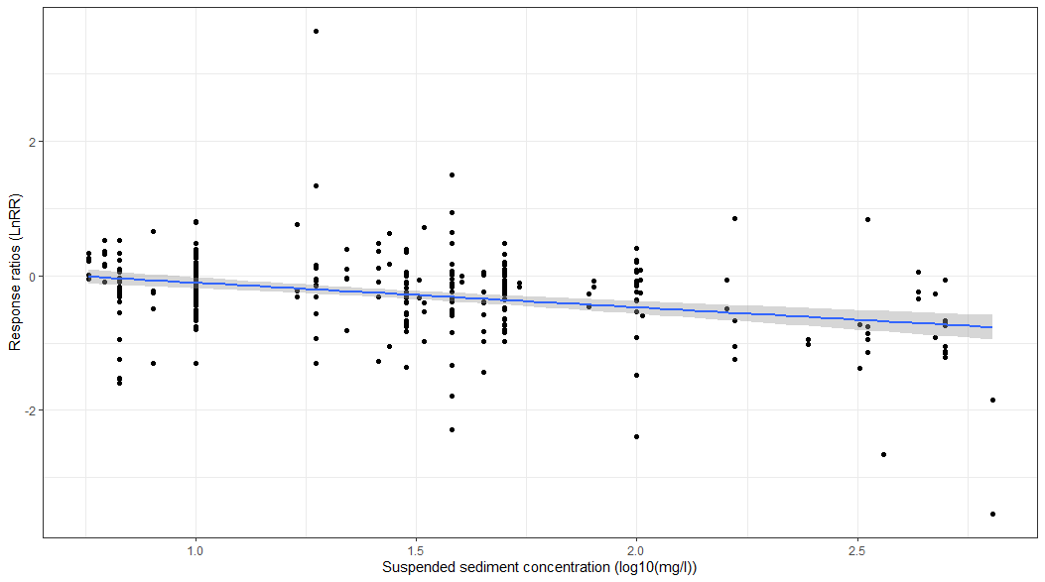
a)
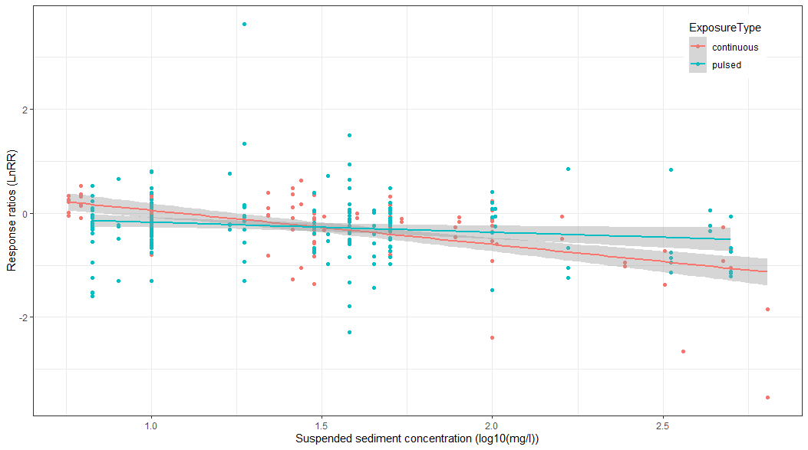
b)
Figure 1. The relationship between suspended sediment concentrations (log-10 transformed) and natural-log response ratios (LnRR) for deep-sea animals in general (a) and by exposure type (b). The log-10 transformation means that the value on the x-axis is the exponent over a base of 10 (e.g., 2 would mean 10² = 100 mg/l).
4.4. Dose-response curves
Selecting significant responses to suspended sediment concentrations reduced the dataset for the dose-response analyses to 54, and included 29 cnidarians, and 25 poriferan cases, covering 5 feeding, 4 growth, 17 physiological, 8 respiratory and 20 survival cases. The mean duration of exposures for these cases was 42 days (median: 6.5 days), with a range of 4 hours and 9 months. Full tables are presented in Appendix B, while shortened versions are included here.
4.4.1 General dose response
A general dose response relationship was derived based on sediment concentrations that elicited significant responses (Figure 2). This dose-response relationship showed that some individuals may respond to very low sediment concentrations (Table 3), with 1% of the individuals responding to concentrations of 2 mg/l (1-4 mg/l 95% confidence interval). Half of the individuals in the dataset respond significantly to sediment concentrations of 53 mg/l (44-76 mg/l 95% confidence interval), while at concentrations between 182-493 mg/l 90% of the species could be significantly affected.
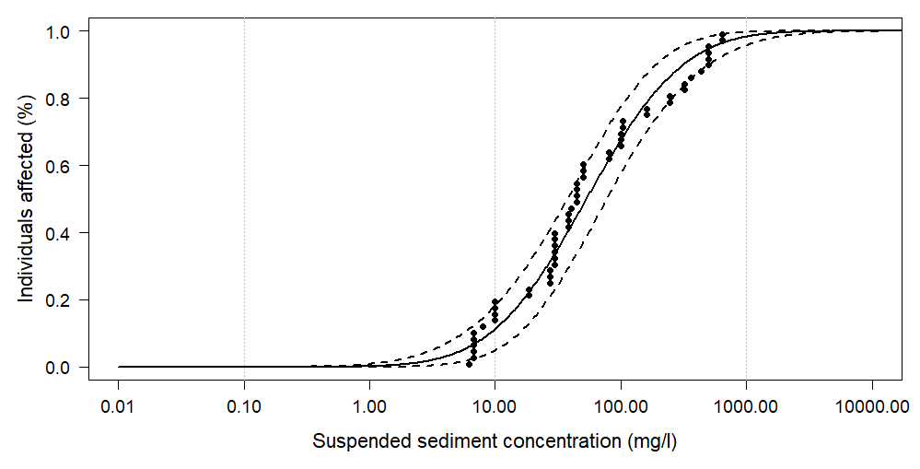Figure 2. Dose-response relationship based on deep-sea data only. Note the logarithmic nature of the x axis. Individual data points included in this analysis: n = 54.
Table 3. Dose-response values (mean and the lower and upper bounds of the 95% Confidence Interval (C.I.)) against different levels of individuals affected (%). Sediment concentrations (mg/l) were rounded to the nearest integer. See Appendix B Table S2 for the full table.
General (mg/l)
Affected (%) | 2.5% C.I. | Mean | 97.5% C.I.
99 | 600 | 1226 | 2516
95 | 297 | 508 | 862
90 | 182 | 306 | 493
75 | 89 | 133 | 203
50 | 36 | 53 | 76
25 | 14 | 21 | 33
10 | 6 | 9 | 15
5 | 3 | 6 | 10
1 | 1 | 2 | 4

Experiments that demonstrated significant deep-sea animal responses at low sediment concentrations were often long exposure (3-9 months) periods. Therefore, additional dose-response relationships were created that investigated the effect of exposure length, with acute (7 days or less) and chronic (>7 days) exposures. In addition, as there were also differences in the exposure type (continuous and pulsed), highlighted also by the second mixed-effect model, separate dose-response relationships were established for this factor, too. Further, while the mixed-effect models did not show significant differences between taxonomic groups, separate dose-response relationships were created for Cnidaria and Porifera, as shallow-water research has shown multiple times that there are taxonomic differences in the sensitivities to suspended sediments. Last, separate dose-response relationships were established for physiological and survival responses, as shallow-water research has often shown that different responses are elicited at different sediment concentrations.
4.4.2 Exposure length: acute vs chronic
When separate dose response relationships are established based on data from either acute or chronic exposures, the sensitivities change, showing that significant responses to suspended sediments are elicited at lower sediment concentrations under chronic exposures compared to acute exposures (Figure 3). The difference between these distributions is statistically supported (D=0.076, p=0.0062). The difference in sensitivities become apparent at relatively low sediment concentrations. For example, when sediment concentrations are around 15 mg/l, about 20% of individuals could be affected if the exposures were acute, while as much as 35% of individuals could be affected if the exposures were chronic (Table 4). As a further illustration, comparing sediment concentration levels where 50% of the individuals could be affected, this would result from 66 mg/l (95% C.I.: 41-100 mg/l) for acute exposures and 40 mg/l (95% C.I.: 22-72 mg/l) for chronic exposures, implying roughly a third to half less sediment concentration than the acute exposure values. The Wilcoxon rank sum test demonstrated, however, that the location of the two dose-response relationships was not statistically different (W = 476530, p = 0.07), which is also highlighted by the overlap in the dose-response relationships, especially at very high sediment concentrations.
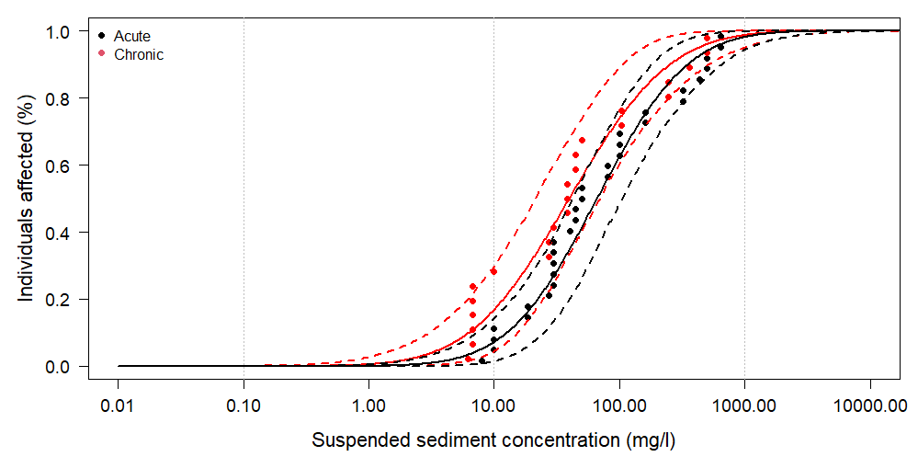
Figure 3. Dose-response relationships based on deep-sea data separated by exposure length (acute exposures (7 days or less) or chronic exposures (more than 7 days exposure)). Note the logarithmic nature of the x axis. Sample sizes: acute: n = 31; chronic: n = 23.
Table 4. Dose-response values (mean and the lower and upper values of the 95% Confidence Interval (C.I.) against different levels of individuals affected (%) split across acute (7 days or less) and chronic (more than 7 days) exposures. Sediment concentrations (mg/l) are rounded to the nearest integer. See Appendix B Table S3 for the full table.
Exposure length (mg/l)
 | Acute |  |  | Chronic
Affected (%) | 2.5% C.I. | Mean | 97.5% C.I. | 2.5% C.I. | Mean | 97.5% C.I.
99 | 548 | 1261 | 3153 | 320 | 1014 | 3435
95 | 265 | 517 | 1077 | 161 | 391 | 1057
90 | 189 | 330 | 602 | 107 | 229 | 510
75 | 91 | 156 | 259 | 53 | 103 | 201
50 | 41 | 66 | 100 | 22 | 40 | 72
25 | 18 | 29 | 47 | 8 | 15 | 29
10 | 7 | 13 | 24 | 3 | 7 | 14
5 | 4 | 8 | 16 | 2 | 4 | 9
1 | 1 | 3 | 8 | 0 | 2 | 5

4.4.3 Exposure type: Continuous vs pulsed
Besides duration, a factor that could affect the sensitivity of deep-sea animals to suspended sediments is the type of exposure. While the second mixed-effect model indicated that increasing sediment concentrations did not have a relationship with response ratios of animals exposed to pulsed treatments, this does not mean animals cannot be significantly affected. It simply shows that responses are not getting significantly worse (as is the case with the continuous treatments) when exposed to higher and higher sediment concentrations. That is, stronger or weaker responses can be expected across a range of sediment concentrations. The two dose-response relationships are similar in distribution (D = 0.057, p = 0.08), but there is a shift in the location of the dose-response relationships (W = 447482, p = 4.76$×$10⁻⁵). Unexpectedly, the pulsed dose-response relationships show higher sensitivities for animals exposed to sediments compared to animals from continuous treatments (Figure 4; Table 5).
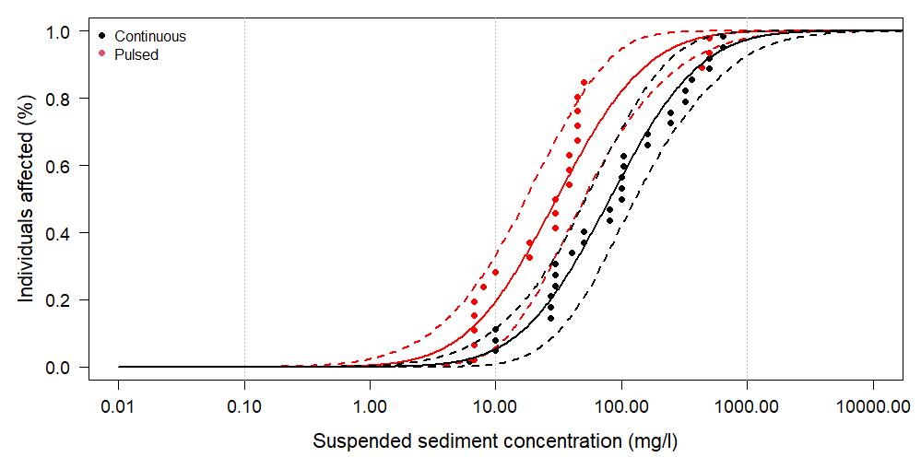
Figure 4. Dose-response curves based on deep-sea data separated by exposure type (continuous or pulsed exposures). Note the logarithmic nature of the x axis. Sample size: continuous: n = 31; pulsed: n = 23.
Table 5. Dose-response values (mean and the lower and upper values of the 95% Confidence Interval (C.I.) against different levels of individuals affected (%) split across continuous and pulsed exposures. Sediment concentrations (mg/l) are rounded to the nearest integer. See Appendix B Table S4 for the full table.
Exposure type (mg/l)
 | Continuous |  |  | Pulsed
Affected (%) | 2.5% C.I. | Mean | 97.5% C.I. | 2.5% C.I. | Mean | 97.5% C.I.
99 | 667 | 1533 | 3830 | 198 | 560 | 1680
95 | 323 | 629 | 1310 | 107 | 238 | 582
90 | 230 | 402 | 733 | 74 | 147 | 302
75 | 111 | 191 | 315 | 39 | 71 | 131
50 | 50 | 80 | 122 | 18 | 30 | 52
25 | 22 | 35 | 57 | 7 | 13 | 23
10 | 9 | 16 | 29 | 3 | 6 | 12
5 | 5 | 10 | 19 | 2 | 4 | 8
1 | 2 | 4 | 10 | 1 | 2 | 4

4.4.4 Phylum: Cnidaria vs Porifera
The two separate dose-response relationships for cnidarians and poriferans highlight one issue with the data coverage: there may be taxonomic-specific responses to suspended sediments (Figure 5, Table 6). The difference in the sensitivities to suspended sediments between these two phyla was statistically supported for both the shape in the relationships (D=0.234, p<2.2$×$10⁻¹⁶) and changes in location (W = 464799, p = 0.006406). What this implies is that at lower sediment concentrations, the two phyla are unlikely to differ, as indicated by the overlap of the 95% confidence intervals up to values that could potentially affect 40% of individuals. Above this, however, the two phyla show marked differences in their sensitivities, and sponges respond more strongly to increased sediment concentrations than cnidarians. Based on the results presented here, 50% of cnidarian individuals could be affected by suspended sediment concentrations between 37-122 mg/l, while 50% of the poriferan individuals could be affected by sediment concentrations between 28-61 mg/l, and such differences continue for higher percentages of individuals affected.
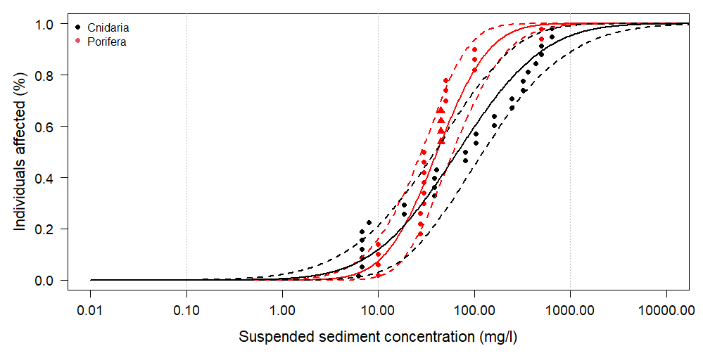
Figure 5. Dose-response relationships based on deep-sea data separated by phyla (cnidarians and poriferans). Demospongiae are indicated by a circle, while Hexactinellida are indicated by a triangle. Note the logarithmic nature of the x axis. Sample size: Cnidaria: n = 29; Porifera: n = 25.
Table 6. Dose-response values (mean and the lower and upper values of the 95% Confidence Interval (C.I.) against different levels of individuals affected (%) split across phyla. Sediment concentrations (mg/l) are rounded to the nearest integer. See Appendix B Table S5 for the full table.
Phylum (mg/l)
 | Cnidaria |  |  | Porifera
Affected (%) | 2.5% C.I. | Mean | 97.5% C.I. | 2.5% C.I. | Mean | 97.5% C.I.
99 | 862 | 2489 | 7904 | 174 | 372 | 796
95 | 369 | 872 | 2194 | 107 | 193 | 358
90 | 226 | 498 | 1098 | 86 | 140 | 234
75 | 104 | 196 | 367 | 51 | 78 | 118
50 | 37 | 68 | 122 | 28 | 41 | 61
25 | 13 | 23 | 44 | 14 | 22 | 32
10 | 4 | 9 | 19 | 7 | 12 | 20
5 | 2 | 5 | 12 | 5 | 8 | 15
1 | 1 | 2 | 5 | 2 | 4 | 9

4.4.4 Response category: physiology and survival
Given the condition of at least 15 data points, there were only sufficient data available to examine physiology and survival responses to investigate response category-specific dose-response relationships. The dose-response relationships for the two selected response categories (Figure 6, Table 7) highlight that there is a difference in sensitivities between physiological and survival responses, both in the shape (D = 0.317, p < 2.2$×$10⁻¹⁶) and location (W = 565494, p = 3.84 $×$10⁻⁷). Physiological responses included responses in biomarkers and in metabolic responses. It is generally accepted that biomarkers are useful indicators for responses to impacts as they are often the first to occur. Meanwhile, changes in survival are the result of integrative effects (e.g., reduced feeding opportunities, reduced energy storage, increased energetic costs because of respiration, maintenance, or removal of sediment particles, etc.) and such responses occur more often at higher sediment concentrations. The two dose-response relationships separate around 30-40 mg/l; at higher concentrations, there is a stronger increase in the percent of individuals affected in physiological responses than in survival responses.
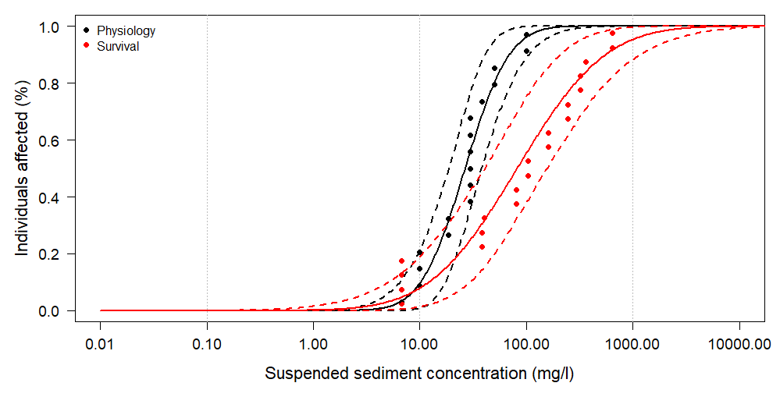
Figure 6. Dose-response relationships based on deep-sea data separated by two response categories (physiology and survival). Note the logarithmic nature of the x axis. Sample sizes: physiology: n = 17; survival: n = 20.
Table 7. Dose-response values (mean and the lower and upper values of the 95% Confidence Interval (C.I.) against different levels of individuals affected (%) split across continuous and pulsed exposures. Sediment concentrations (mg/l) are rounded to the nearest integer. See Appendix B Table S6 for the full table.
Response category (mg/l)
 | Physiology |  |  | Survival
% Affected | 2.5% C.I. | Mean | 97.5% C.I. | 2.5% C.I. | Mean | 97.5% C.I.
99% | 74 | 139 | 294 | 662 | 2335 | 8480
95% | 51 | 85 | 156 | 337 | 907 | 2398
90% | 41 | 66 | 112 | 227 | 496 | 1240
75% | 29 | 42 | 64 | 107 | 215 | 452
50% | 19 | 27 | 38 | 41 | 83 | 165
25% | 11 | 16 | 24 | 15 | 31 | 62
10% | 7 | 11 | 17 | 5 | 13 | 31
5% | 5 | 8 | 14 | 3 | 8 | 20
1% | 2 | 5 | 9 | 1 | 3 | 10

5. Discussion and Conclusions

5.1 Summary of key findings
Suspended sediment concentrations affect most of the deep-sea animals examined in this review, eliciting a range of responses from feeding to survival (Table 1). Increasing suspended sediments generally result in negative responses but this may depend on the exposure regime (Figure 1). A general dose-response curve was established, demonstrating how certain levels of sediment concentrations may affect deep-sea animals overall based on the current available data. Further analyses by taxa, duration and type of exposure added more nuances to help understand the nature and extent of responses to be considered in evaluation of environmental threshold values for suspended sediments. Below we briefly summarise and discuss some of these findings.
Continuous or repeated plumes
There was strong evidence from the second mixed effect model that when animals are continuously exposed to suspended sediments, their responses will increasingly be more negative with increasing sediment concentrations, while the presence of recovery periods (pulsed exposures) removes this relationship (Figure 1b). That is, the availability of recovery periods under frequent sediment exposure could reduce (but not remove) impacts. Such a response has also been observed in shallow-water environments (Robinson et al., 2010). However, and slightly surprisingly, there is a difference in the sensitivity between exposure types (Figure 4, Table 5), with animals experiencing pulsed exposures appearing to be more sensitive than animals experiencing continuous exposures. This may be an effect of duration as well – the pulsed data came predominately from chronic exposures (15 values, compared to 6 values for acute exposures), while the continuous data came predominately from acute exposures (22 values, compared to 9 for chronic exposures). As some of these comparisons (pulsed and acute, continuous and chronic) had fewer than 15 datapoints, no separate analyses were run to disentangle these separate effects. Thus, while it is likely that recovery periods can convey some protection, it is unclear how much, and it is not possible based on the available data to determine if there is a minimal length of recovery needed and what this would be. The studies that incorporated a pulsed design in their sediment exposures usually had a 12 hour on/12 hour off exposure regime, limiting the opportunity to test for these effects.
Duration of exposures
Duration was not investigated in the mixed effect models because of design issues between the different studies included. In shallow-water experiments, it has been established that exposure duration affects responses and typically the longer the exposure, the higher the sensitivity becomes. The dose-response relationships presented here in Figure 3 indicate that chronic exposures (those lasting for more than 7 days) showed higher sensitivities for similar sediment concentrations than acute exposures (those lasting for 7 days or less). Although the available data on deep-sea animal responses is insufficient for detailed analysis, this result indicates the duration of exposure may increase sensitivities to mining plumes.
Taxonomic differences
Most of the data used in the analyses presented come from corals or sponges (with several species within each of these groups), and the dose-response relationships are only based on coral or sponge data. The dose-response relationship comparison between these two groups highlights that there can be potential taxonomic-specific responses in sensitivities to suspended sediments (Figure 5, Table 6). While at low sediment concentrations the two phyla show similar sensitivity levels (in terms of the percentage of individuals affected), above these sediment concentrations sponges become more sensitive to sediment concentrations than corals. Whether other groups show such differences, or whether there are even more specific responses at other taxonomic levels is not known. Shallow-water analyses have often demonstrated species-specific sediment thresholds thus it would not be surprising if such differences were present in deep-sea taxa, too. Note that the general dose-response relationship falls between the two phyla relationships.
Response choice can affect sensitivities
Suspended sediments can elicit a range of biological responses, which are also not mutually exclusive. Two categories of responses were further investigated and showed a pattern also observed in shallow-water animals: physiological responses tend to be more sensitive than survival responses (Figure 6, Table 7). However, the data were inadequate to support quantification of several other important responses (e.g., respiration, growth effects).

5.2 Mining scenarios
Mining plumes are not constant in their sediment concentration but dilute as larger sediment particles settle, and plumes disperse. As an illustration of the context of the study concentrations analysed here in a mining situation we compare our dose-response values against a recent study that investigated collector-plume behaviour right after it was created by a pre-prototype nodule collector vehicle (Muñoz-Royo et al., 2022). Interpolated plume sediment concentrations across the seafloor showed that sediment concentrations could reach as high as 100 mg/l, although mostly the plume sediment concentrations were around 1-10 mg/l (Muñoz-Royo et al., 2022). Comparing these sediment concentrations against the values of the dose-response relationships estimated in the present analysis (Table 8) show that there is quite a lot of variation regarding how many animal individuals may be affected. For example, at a concentration of 10 mg/l, the number of individuals affected ranged from ≤10-≤30%, with the lowest percentage based on continuous plume exposures, while the highest percentage estimated came from the dose-response relationship based on pulsed plume exposure; more commonly between 15-20% of individuals would be affected based on the different dose-response relationships.
Table 8. Percentage of individuals according to different dose-response estimates against the suspended sediment concentrations (SSC) measured in an in situ test of a collector plume, including the highest estimated SSC and the more common values across the collector plume, taken from Muñoz-Royo et al. (2022).
 | Dose-response relationship
SSC | General | Acute | Chronic | Continuous | Pulsed | Corals | Sponges | Physiology | Survival
100 | ≤75% | ≤75% | ≤85% | ≤70% | ≤90% | ≤70% | ≤90% | ≤99% | ≤70%
10 | ≤15% | ≤15% | ≤25% | ≤10% | ≤30% | ≤20% | ≤15% | ≤20% | ≤15%
1 | ≤1% | ≤1% | ≤1% | <1% | ≤1% | ≤1% | <1% | <1% | ≤1%

6. Uncertainties, gaps and limitations

6.1 Sample sizes
While sufficient samples were available to undertake this study, sample sizes still remain limited, in various ways. 325 responses were used in the mixed effect models, but several factors were unable to be included in the analyses, likely because of lack of data coverage or low replication of specific groups within that factor. For example, barite was tested at 4 different sediment concentrations, bentonite at 3, crushed rock at 5, crushed polymetallic sulphides at 2, and drill cuttings at 8 sediment concentration levels, while natural sediments were tested at 24 different sediment concentrations. Given the dominance of natural sediments used, which is of main interest here, it may not be a surprise that no evidence was obtained for the effect of different sediment types. Likewise, the different Classes that were studied varied greatly in the sediment concentrations they were tested at, with Anthozoa tested at 24 sediment concentrations (ranging 5.7-640 mg/l), Bivalvia only at 1 concentration (10 mg/l), Demospongiae at 9 different sediment concentrations (10-500 mg/l), Hexactinellida also only at 1 sediment concentration (44.9 mg/l) and Scyphozoa at 4 sediment concentrations (17-333 mg/l). In addition, the replication in some of these combinations could be just 1 response (e.g., drill cuttings at 10 mg/l, crushed rock at 100 mg/l and 500 mg/l, natural sediment at 362 mg/l), while others could be as high as 63 (Demospongiae at 10 mg/l). This all affects how well different groups within factors can be estimated, and thus the absence of a taxonomic or sediment type effect may be related to the sample sizes and data coverage rather than the lack of evidence for an effect. The dose-response relationships were based, at maximum, on 54 responses (general dose-response curve), excluding the bivalve and jellyfish data given their low data coverage or that they were not benthic organisms. The sample size on which other dose-response relationships were based were low, with the lowest only being informed by 17 data points. There is a clear and pressing need for studies that fill in some of these gaps.

6.2 Sediment type, sharpness and size
Various sediment types were used to expose deep-sea animals to suspended sediments, influenced by the focus of the specific study. This included studies focused on the effects of mine tailings (Kutti et al., 2015; Scanes et al., 2024, 2018), drilling muds and drill cuttings (Edge et al., 2016; Järnegren et al., 2017; Kutti et al., 2015; Larsson et al., 2013), and natural sediments for studying the effect of bottom trawling (Bilan et al., 2023; Brooke et al., 2009; Larsson et al., 2013; Mobilia et al., 2023, 2021; Tjensvoll et al., 2013; Wurz et al., 2021), deep-sea mining (Carreiro-Silva et al., 2022; Mobilia et al., 2023, 2021; Stenvers et al., 2023; Wurz et al., 2024), or resuspension events from strong currents and storms (Brooke et al., 2009). These different types of sediments differed in particle size, sharpness, minerology and potentially organic carbon content. Shallow-water experiments have demonstrated that the origin (influencing nutritional quality), size and sharpness of sediment particles can influence animal response to suspended sediments (Bilotta and Brazier, 2008; Donohue and Irvine, 2003; Robinson et al., 2010), and this was also found in one deep-sea experiment (Kutti et al., 2015). We made the choice to include all these different sediment types in the analyses knowing this could increase the uncertainty in the analyses. This choice was made to increase the number of studies that could be incorporated in the analyses. While the analyses presented here did not find statistical support for differences in responses to these different sediment types, it is possible this does not reflect a lack of biological response, but a lack of data coverage, as described above. For those interested in understanding some of these responses, please refer to Appendix C (section 1) for a discussion on the effects of particle size, sharpness, mineralogy on animal responses to suspended sediments.

6.3 Life stage effects
The majority of studies included in the analyses here focused on adults. Yet, shallow-water research has shown that responses to suspended sediments differ between different life stages, and that there are specific effects for early life stages. The availability of just one study on a deep-sea animal early life stage does not allow for an assessment of life stage-specific responses and determining whether their sensitivities are different. Such studies are therefore highly needed. This is especially important regarding the maintenance of connectivity of populations if suspended sediments affect deep-sea animal fertilization success, embryonic development, larval swimming, settlement and duration, or survival across these early life stages. For a discussion on how different life stages may be affected by suspended sediments, please see Appendix C (section 2).

6.4 Response choice
While the combined studies showed a wide range of responses, many more responses can be addressed to further our understanding of suspended sediment impacts on deep-sea animals (Table 1). The challenge remains to study deep-sea animals in laboratory settings because many species are difficult to capture, retrieve, safely bring to a laboratory and maintain them for long enough to conduct experiments and observe responses. Yet, it is clear from the results presented here that different response types can be elicited at different sediment concentrations, and when this is not accounted for, can introduce uncertainty in the results. This was apparent in the variation captured by the random effect response category in the first mixed effect model (although this effect was removed when other factors were included in the second model) and is shown in the dose-response relationships for two different response categories.

6.5 Experimental design
The different experimental designs used in the deep-sea studies will likely have increased uncertainty. A previous study noted the high variance explained by studies (capturing the different experimental designs), rather than factors of interest (van der Grient and Drazen, 2022). A similar observation was made for the first mixed effect model, where much of the variation was explained by the random factors. However, in the second mixed effect model this difference between the marginal and conditional R² was much larger, indicating that the incorporation of more fixed effects potentially captured much of the variation coming from experimental design differences.

6.6 Geographical locations and natural background sediment concentrations
Most of the studies included here used specimens from Norwegian waters. It is important to increase geographical variation, and ideally this will also include areas where the ISA regulates mining. This is to verify the effect of natural background conditions which vary between geographical locations, and could potentially influence the tolerance and sensitivity of animals to specific levels of suspended sediments (van der Grient and Drazen, 2022).

6.7 Future research
Several key areas for further research have already been part of this report. A summary for research areas is presented in Appendix C (section 3).

7. Suggestions

7.1 Suggestions regarding the use of threshold values
As this report has outlined, a general dose-response relationship can be derived from the available deep-sea literature. There are still several factors that ideally require further investigation as these can influence sensitivity thresholds, but the data are currently inadequate to assess these factors. Therefore, we suggest there are several options for discussion which this meta-analysis can help inform.
- Evaluate whether the general dose-response relationship can be used, which despite the uncertainties covered above, contains available deep-sea benthic data, and which shows similarities in sensitivity values with shallow-water marine environments.
- Consider the phylum dose-response relationship and the response category dose-response relationship showing that sensitivity levels can vary based on these two factors. Variation in responses between taxa, and the nature of the response, can be relevant for acting as early-warning indicators.
- Consider how to take into account the effect of duration causing increased sensitivities to suspended sediments, and recovery periods. The inclusion of the dose-response relationship based on exposure type (continuous – without recovery periods; pulsed – including recovery periods) or exposure length (acute exposures vs. chronic exposures) would encompass potential effects from these factors.

8. Acknowledgements
We would like to thank Andrew Sweetman, Ana Colaço and Matthias Haeckel for providing data advice and support in data collection, and specifically Vonda Cummings and Jenny Beaumont from NIWA for providing further data. We wish to express thanks for the support from the ISA Secretariat, and in particular Luciana De Melo Santos Genio, and for providing funding through an ISA contract for JvdG. We thank the IEG subgroup on turbidity and settling of resuspended sediments for their suggestions and comments.

9. References
Alurralde, G., Fuentes, V.L., Maggioni, T., Movilla, J., Olariaga, A., Orejas, C., Schloss, I.R., Tatián, M., 2019. Role of suspension feeders in Antarctic pelagic-benthic coupling: Trophic ecology and potential carbon sinks under climate change. Marine Environmental Research 152, 104790. https://doi.org/10.1016/j.marenvres.2019.104790
Arendt, K.E., Dutz, J., Jonasdottir, S.H., Jung-Madsen, S., Mortensen, J., Moller, E.F., Nielsen, T.G., 2011. Effects of suspended sediments on copepods feeding in a glacial influenced sub-Arctic fjord. Journal of Plankton Research 33, 1526–1537. https://doi.org/10.1093/plankt/fbr054
Armsworthy, S.L., MacDonald, B.A., Ward, J.E., 2001. Feeding activity, absorption efficiency and suspension feeding processes in the ascidian, Halocynthia pyriformis (Stolidobranchia: Ascidiacea): responses to variations in diet quantity and quality. Journal of Experimental Marine Biology and Ecology 260, 41–69.
Au, D., Pollino, C., Wu, R., Shin, P., Lau, S., Tang, J., 2004. Chronic effects of suspended solids on gill structure, osmoregulation, growth, and triiodothyronine in juvenile green grouper Epinephelus coioides. Marine Ecology Progress Series 266, 255–264. https://doi.org/10.3354/meps266255
Bannister, R.J., Battershill, C.N., De Nys, R., 2012. Suspended sediment grain size and mineralogy across the continental shelf of the Great Barrier Reef: Impacts on the physiology of a coral reef sponge. Continental Shelf Research 32, 86–95. https://doi.org/10.1016/j.csr.2011.10.018
Bates, D., Mächler, M., Bolker, B.M., Walker, S.C., 2015. Fitting linear mixed-effects models using lme4. Journal of Statistical Software 67, 1–48.
Bell, J.J., McGrath, E., Biggerstaff, A., Bates, T., Bennett, H., Marlow, J., Shaffer, M., 2015. Sediment impacts on marine sponges. Marine Pollution Bulletin 94, 5–13. https://doi.org/10.1016/j.marpolbul.2015.03.030
Bilan, M., Gori, A., Grinyó, J., Biel-Cabanelas, M., Puigcerver-Segarra, X., Santín, A., Piraino, S., Rossi, S., Puig, P., 2023. Vulnerability of six cold-water corals to sediment resuspension from bottom trawling fishing. Marine Pollution Bulletin 196, 115423. https://doi.org/10.1016/j.marpolbul.2023.115423
Bilotta, G.S., Brazier, R.E., 2008. Understanding the influence of suspended solids on water quality and aquatic biota. Water Research 42, 2849–2861. https://doi.org/10.1016/j.watres.2008.03.018
Boehlert, G.W., Morgan, J.B., 1985. Turbidity enhances feeding abilities of larval Pacific herring, Clupea harengus pallasi. Hydrobiologia 123, 161–170. https://doi.org/10.1007/BF00018978
Bricelj, V.M., Malouf, R.E., De Quillfeldt, C., 1984. Growth of juvenile Mercenaria mercenaria and the effect of resuspended bottom sediments. Marine Biology 84, 167–173. https://doi.org/10.1007/BF00393001
Brooke, S., Holmes, M., Young, C., 2009. Sediment tolerance of two different morphotypes of the deep-sea coral Lophelia pertusa from the Gulf of Mexico. Marine Ecology Progress Series 390, 137–144. https://doi.org/10.3354/meps08191
Bryce, S.A., Lomnicky, G.A., Kaufmann, P.R., 2010. Protecting sediment-sensitive aquatic species in mountain streams through the application of biologically based streambed sediment criteria. Journal of the North American Benthological Society 29, 657–672. https://doi.org/10.1899/09-061.1
Carrasco-Malio, A., Díaz, M., Mella, M., Montoya, M.J., Miranda, A., Landaeta, M.F., Sánchez, G., Hidalgo, M.E., 2014. Are the intertidal fish highly resistant to UV-B radiation? A study based on oxidative stress in Girella laevifrons (Kyphosidae). Ecotoxicology and Environmental Safety 100, 93–98. https://doi.org/10.1016/j.ecoenv.2013.07.030
Carreiro-Silva, M., Martins, I., Riou, V., Raimundo, J., Caetano, M., Bettencourt, R., Rakka, M., Cerqueira, T., Godinho, A., Morato, T., Colaço, A., 2022. Mechanical and toxicological effects of deep-sea mining sediment plumes on a habitat-forming cold-water octocoral. Frontiers in Marine Science 9, 915650. https://doi.org/10.3389/fmars.2022.915650
Chapman, J.M., Proulx, C.L., Veilleux, M.A.N., Levert, C., Bliss, S., André, M.-È., Lapointe, N.W.R., Cooke, S.J., 2014. Clear as mud: A meta-analysis on the effects of sedimentation on freshwater fish and the effectiveness of sediment-control measures. Water Research 56, 190–202. https://doi.org/10.1016/j.watres.2014.02.047
Cumming, H., Herbert, N.A., 2016. Gill structural change in response to turbidity has no effect on the oxygen uptake of a juvenile sparid fish. Conservation Physiology 4, 1–12. https://doi.org/10.1093/conphys/cow033
De Robertis, A., Ryer, C.H., Veloza, A., Brodeur, R.D., 2003. Differential effects of turbidity on prey consumption of piscivorous and planktivorous fish. Canadian Journal of Fisheries and Aquatic Sciences 60, 1517–1526. https://doi.org/10.1139/f03-123
Donohue, I., Garcia Molinos, J., 2009. Impacts of increased sediment loads on the ecology of lakes. Biological Reviews 84, 517–531. https://doi.org/10.1111/j.1469-185X.2009.00081.x
Donohue, I., Irvine, K., 2003. Effects of sediment particle size composition on survivorship of benthic invertebrates from Lake Tanganyika, Africa. Archiv für Hydrobiologie 157, 131–144. https://doi.org/10.1127/0003-9136/2003/0157-0131
Edge, K.J., Johnston, E.L., Dafforn, K.A., Simpson, S.L., Kutti, T., Bannister, R.J., 2016. Sub-lethal effects of water-based drilling muds on the deep-water sponge Geodia barretti. Environmental Pollution 212, 525–534. https://doi.org/10.1016/j.envpol.2016.02.047
Ellis, J., Cummings, V., Hewitt, J., Thrush, S., Norkko, A., 2002. Determining effects of suspended sediment on condition of a suspension feeding bivalve (Atrina zelandica): results of a survey, a laboratory experiment and a field transplant experiment. Journal of Experimental Marine Biology and Ecology 267, 147–174. https://doi.org/10.1016/S0022-0981(01)00355-0
Engstrom-Ost, J., Candolin, U., 2007. Human-induced water turbidity alters selection on sexual displays in sticklebacks. Behavioral Ecology 18, 393–398. https://doi.org/10.1093/beheco/arl097
Erftemeijer, P.L.A., Riegl, B., Hoeksema, B.W., Todd, P.A., 2012. Environmental impacts of dredging and other sediment disturbances on corals: A review. Marine Pollution Bulletin 64, 1737–1765. https://doi.org/10.1016/j.marpolbul.2012.05.008
Fabricius, K.E., 2005. Effects of terrestrial runoff on the ecology of corals and coral reefs: review and synthesis. Marine Pollution Bulletin 50, 125–146. https://doi.org/10.1016/j.marpolbul.2004.11.028
Franklin, A.M., Ysrael, M., Lewis, S.M., 2018. Turbidity affects stomatopod contest behaviours and response to UV cues. Journal of Experimental Marine Biology and Ecology 506, 100–106. https://doi.org/10.1016/j.jembe.2018.06.005
Fuentes, V., Alurralde, G., Meyer, B., Aguirre, G.E., Canepa, A., Wölfl, A.-C., Hass, H.C., Williams, G.N., Schloss, I.R., 2016. Glacial melting: an overlooked threat to Antarctic krill. Scientific Reports 6, 27234. https://doi.org/10.1038/srep27234
Gilmour, J., 1999. Experimental investigation into the effects of suspended sediment on fertilisation, larval survival and settlement in a scleractinian coral. Marine Biology 135, 451–462. https://doi.org/10.1007/s002270050645
Griffin, F.J., Smith, E.H., Vines, C.A., Cherr, G.N., 2009. Impacts of Suspended Sediments on Fertilization, Embryonic Development, and Early Larval Life Stages of the Pacific Herring, Clupea pallasi. Biological Bulletin 216, 175–187.
Hansen, B., Hansen, P.J., Nielsen, T.G., 1991. Effects of large nongrazable particles on clearance and swimming behaviour of zooplankton. Journal of Experimental Marine Biology and Ecology 152, 257–269. https://doi.org/10.1016/0022-0981(91)90218-L
Haven, D.S., Morales-Alamo, R., 1966. Aspects of Biodeposition by Oysters and Other Invertebrate Filter Feeders. Limnology and Oceanography 11, 487–498.
Hedges, L.V., Gurevitch, J., Curtis, P.S., 1999. The meta-analysis of response ratios in experimental ecology. Ecology 80, 1150–1156.
Helenius, L.K., Borg, J.P.G., Nurminen, L., Leskinen, E., Lehtonen, H., 2013. The effects of turbidity on prey consumption and selection of zooplanktivorous Gasterosteus aculeatus L. Aquatic Ecology 47, 349–356. https://doi.org/10.1007/s10452-013-9448-x
Hess, S., Prescott, L.J., Hoey, A.S., McMahon, S.A., Wenger, A.S., Rummer, J.L., 2017. Species-specific impacts of suspended sediments on gill structure and function in coral reef fishes. Proceedings of the Royal Society B: Biological Sciences 284, 20171279. https://doi.org/10.1098/rspb.2017.1279
Hess, S., Wenger, A.S., Ainsworth, T.D., Rummer, J.L., 2015. Exposure of clownfish larvae to suspended sediment levels found on the Great Barrier Reef: Impacts on gill structure and microbiome. Scientific Reports 5, 10561. https://doi.org/10.1038/srep10561
Heuschele, J., Mannerla, M., Gienapp, P., Candolin, U., 2009. Environment-dependent use of mate choice cues in sticklebacks. Behavioral Ecology 20, 1223–1227. https://doi.org/10.1093/beheco/arp123
Hewitt, J.E., Norkko, J., 2007. Incorporating temporal variability of stressors into studies: An example using suspension-feeding bivalves and elevated suspended sediment concentrations. Journal of Experimental Marine Biology and Ecology 341, 131–141. https://doi.org/10.1016/j.jembe.2006.09.021
Hewitt, J.E., Pilditch, C.A., 2004. Environmental history and physiological state influence feeding responses of Atrina zelandica to suspended sediment concentrations. Journal of Experimental Marine Biology and Ecology 306, 95–112. https://doi.org/10.1016/j.jembe.2004.01.003
Humanes, A., Ricardo, G.F., Willis, B.L., Fabricius, K.E., Negri, A.P., 2017. Cumulative effects of suspended sediments, organic nutrients and temperature stress on early life history stages of the coral Acropora tenuis. Scientific Reports 7, 44101. https://doi.org/10.1038/srep44101
Humphrey, C., Weber, M., Lott, C., Cooper, T., Fabricius, K., 2008. Effects of suspended sediments, dissolved inorganic nutrients and salinity on fertilisation and embryo development in the coral Acropora millepora (Ehrenberg, 1834). Coral Reefs 27, 837–850. https://doi.org/10.1007/s00338-008-0408-1
Järnegren, J., Brooke, S., Jensen, H., 2017. Effects of drill cuttings on larvae of the cold-water coral Lophelia pertusa. Deep Sea Research Part II: Topical Studies in Oceanography 137, 454–462. https://doi.org/10.1016/j.dsr2.2016.06.014
Järvenpää, M., Lindström, K., 2004. Water turbidity by algal blooms causes mating system breakdown in a shallow-water fish, the sand goby Pomatoschistus minutus. Proceedings of the Royal Society of London. Series B: Biological Sciences 271, 2361–2365. https://doi.org/10.1098/rspb.2004.2870
Jones, R., Bessell-Browne, P., Fisher, R., Klonowski, W., Slivkoff, M., 2016. Assessing the impacts of sediments from dredging on corals. Marine Pollution Bulletin 102, 9–29. https://doi.org/10.1016/j.marpolbul.2015.10.049
Kang, H.-K., 2012. Effects of suspended sediments on reproductive responses of Paracalanus sp. (Copepoda: Calanoida) in the laboratory. Journal of Plankton Research 34, 626–635. https://doi.org/10.1093/plankt/fbs033
Kemp, P., Sear, D., Collins, A., Naden, P., Jones, I., 2011. The impacts of fine sediment on riverine fish. Hydrological Processes 25, 1800–1821. https://doi.org/10.1002/hyp.7940
Kiørboe, T., Mølenberg, F., Nøhr, O., 1980. Feeding, particle selection and carbon absorption in Mytilus edulis in different mixtures of algae and resuspended bottom material. Ophelia 19, 193–205. https://doi.org/10.1080/00785326.1980.10425516
Kjelland, M.E., Woodley, C.M., Swannack, T.M., Smith, D.L., 2015. A review of the potential effects of suspended sediment on fishes: potential dredging-related physiological, behavioral, and transgenerational implications. Environment Systems and Decisions 35, 334–350. https://doi.org/10.1007/s10669-015-9557-2
Klumpp, D., 1984. Nutritional ecology of the ascidian Pyura stolonifera: influence of body size, food quantity and quality on filter-feeding, respiration, assimilation efficiency and energy balance. Marine Ecology Progress Series 19, 269–284. https://doi.org/10.3354/meps019269
Kutti, T., Bannister, R.J., Fosså, J.H., Krogness, C.M., Tjensvoll, I., Søvik, G., 2015. Metabolic responses of the deep-water sponge Geodia barretti to suspended bottom sediment, simulated mine tailings and drill cuttings. Journal of Experimental Marine Biology and Ecology 473, 64–72. https://doi.org/10.1016/j.jembe.2015.07.017
Kuznetsova, A., Brockhoff, P.B., Christensen, R.H.B., 2017. lmerTest Package: Tests in Linear Mixed Effects Models. Journal of Statistical Software 82. https://doi.org/10.18637/jss.v082.i13
Lajeunesse, M.J., 2011. On the meta-analysis of response ratios for studies with correlated and multi-group designs. Ecology 92, 2049–2055.
Larsson, A., Van Oevelen, D., Purser, A., Thomsen, L., 2013. Tolerance to long-term exposure of suspended benthic sediments and drill cuttings in the cold-water coral Lophelia pertusa. Marine Pollution Bulletin 70, 176–188. https://doi.org/10.1016/j.marpolbul.2013.02.033
Lin, H.-P., Charmantier, G., Thuet, P., Trilles, J.-P., 1992. Effects of turbidity on survival, osmoregulation and gill Na+-K+ ATPase in juvenile shrimp Penaeus japonicus. Marine Ecology Progress Series 90, 31–37. https://doi.org/10.3354/meps090031
Lohrer, A.M., Hewitt, J.E., Thrush, S.F., 2006. Assessing far-field effects of terrigenous sediment loading in the coastal marine environment. Marine Ecology Progress Series 315, 13–18.
Lüdecke, D., Ben-Shachar, M., Patil, I., Waggoner, P., Makowski, D., 2021. performance: An R Package for Assessment, Comparison and Testing of Statistical Models. Journal of Open Source Software 6, 3139. https://doi.org/10.21105/joss.03139
Lunt, J., Smee, D.L., 2015. Turbidity interferes with foraging success of visual but not chemosensory predators. PeerJ 3, e1212. https://doi.org/10.7717/peerj.1212
McGrath, E.C., Smith, D.J., Jompa, J., Bell, J.J., 2017. Adaptive mechanisms and physiological effects of suspended and settled sediment on barrel sponges. Journal of Experimental Marine Biology and Ecology 496, 74–83. https://doi.org/10.1016/j.jembe.2017.07.013
Meager, J.J., Domenici, P., Shingles, A., Utne-Palm, A.C., 2006. Escape responses in juvenile Atlantic cod Gadus morhua L.: The effects of turbidity and predator speed. Journal of Experimental Biology 209, 4174–4184.
Meager, J.J., Solbakken, T., Utne-Palm, A.C., Oen, T., 2005. Effects of turbidity on the reactive distance, search time, and foraging success of juvenile Atlantic cod (Gadus morhua). Canadian Journal of Fisheries and Aquatic Sciences 62, 1978–1984. https://doi.org/10.1139/f05-104
Mobilia, V., Cummings, V.J., Clark, M.R., Tracey, D., Bell, J.J., 2021. Short-term physiological responses of the New Zealand deep-sea sponge Ecionemia novaezealandiae to elevated concentrations of suspended sediments. Journal of Experimental Marine Biology and Ecology 541, 151579. https://doi.org/10.1016/j.jembe.2021.151579
Mobilia, V., Tracey, D.M., Cummings, V., Clark, M.R., Woods, L., Bell, J., 2023. Effects of sediment pulses on the deep-sea coral Goniocorella dumosa. New Zealand Journal of Marine and Freshwater Research 1–17. https://doi.org/10.1080/00288330.2023.2230154
Muñoz-Royo, C., Ouillon, R., El Mousadik, S., Alford, M.H., Peacock, T., 2022. An in situ study of abyssal turbidity-current sediment plumes generated by a deep seabed polymetallic nodule mining preprototype collector vehicle. Science Advances 8, eabn1219. https://doi.org/10.1126/sciadv.abn1219
Newcombe, C.P., Jensen, J.O.T., 1996. Channel Suspended Sediment and Fisheries: A Synthesis for Quantitative Assessment of Risk and Impact. North American Journal of Fisheries Management 16, 693–727. https://doi.org/10.1577/1548-8675(1996)016<0693:CSSAFA>2.3.CO;2
O’Connor, J.J., Lecchini, D., Beck, H.J., Cadiou, G., Lecellier, G., Booth, D.J., Nakamura, Y., 2016. Sediment pollution impacts sensory ability and performance of settling coral-reef fish. Oecologia 180, 11–21. https://doi.org/10.1007/s00442-015-3367-6
Phillips, N., Shima, J., 2006. Differential effects of suspended sediments on larval survival and settlement of New Zealand urchins Evechinus chloroticus and abalone Haliotis iris. Marine Ecology Progress Series 314, 149–158. https://doi.org/10.3354/meps314149
Pineda, M.-C., Strehlow, B., Sternel, M., Duckworth, A., Jones, R., Webster, N.S., 2017. Effects of suspended sediments on the sponge holobiont with implications for dredging management. Scientific Reports 7, 4925. https://doi.org/10.1038/s41598-017-05241-z
Pinheiro, M., Caetano, M., Neuparth, T., Barros, S., Soares, J., Raimundo, J., Vale, C., Coimbra, J., Castro, L.F.C., Santos, M.M., 2019. Ecotoxicology of deep-sea environments: Functional and biochemical effects of suspended sediments in the model species Mytilus galloprovincialis under hyperbaric conditions. Science of The Total Environment 670, 218–225. https://doi.org/10.1016/j.scitotenv.2019.03.196
R Core Team, 2024. R: A Language and Environment for Statistical Computing. R Foundation for Statistical Computing.
Ricardo, G.F., Jones, R.J., Clode, P.L., Humanes, A., Negri, A.P., 2015. Suspended sediments limit coral sperm availability. Scientific Reports 5, 18084. https://doi.org/10.1038/srep18084
Ricardo, G.F., Jones, R.J., Clode, P.L., Negri, A.P., 2016a. Mucous Secretion and Cilia Beating Defend Developing Coral Larvae from Suspended Sediments. PLoS ONE 11, e0162743. https://doi.org/10.1371/journal.pone.0162743
Ricardo, G.F., Jones, R.J., Negri, A.P., Stocker, R., 2016b. That sinking feeling: Suspended sediments can prevent the ascent of coral egg bundles. Scientific Reports 6, 21567. https://doi.org/10.1038/srep21567
Riisgård, H.U., Kittner, C., Seerup, D.F., 2003. Regulation of opening state and filtration rate in filter-feeding bivalves (Cardium edule, Mytilus edulis, Mya arenaria) in response to low algal concentration. Journal of Experimental Marine Biology and Ecology 284, 105–127. https://doi.org/10.1016/S0022-0981(02)00496-3
Robbins, I.J., 1984. The regulation of ingestion rate, at high suspended particulate concentrations, by some phleobranchiate ascidians. Journal of Experimental Marine Biology and Ecology 82, 1–10. https://doi.org/10.1016/0022-0981(84)90135-7
Robinson, S.E., Capper, N.A., Klaine, S.J., 2010. The effects of continuous and pulsed exposures of suspended clay on the survival, growth, and reproduction of Daphnia magna. Environmental Toxicology and Chemistry 29, 168–175. https://doi.org/10.1002/etc.4
Robinson, W.E., Wehling, W.E., Morse, P., 1984. The effect of suspended clay on feeding and digestive efficiency of the surf clam, Spisula solidissima (Dillwyn). Journal of Experimental Marine Biology and Ecology 74, 1–12.
Rohatgi, A., 2019. WebPlotDigitizer.
Rosenthal, H., 1971. Wirkungen von ,,Rotschlamm" auf Embryonen und Larven des Herings Clupeaharengus. Helgoländer wissenschaftliche Meeresuntersuchungen 22, 366–376.
Safi, K.A., Hewitt, J.E., Talman, S.G., 2007. The effect of high inorganic seston loads on prey selection by the suspension-feeding bivalve, Atrina zelandica. Journal of Experimental Marine Biology and Ecology 344, 136–148. https://doi.org/10.1016/j.jembe.2006.12.023
Scanes, E., Kutti, T., Fang, J.K.H., Johnston, E.L., Ross, P.M., Bannister, R.J., 2024. The long-lived deep-sea bivalve Acesta excavata is sensitive to the dual stressors of sediment and warming. Marine Pollution Bulletin 202, 116323. https://doi.org/10.1016/j.marpolbul.2024.116323
Scanes, E., Kutti, T., Fang, J.K.H., Johnston, E.L., Ross, P.M., Bannister, R.J., 2018. Mine Waste and Acute Warming Induce Energetic Stress in the Deep-Sea Sponge Geodia atlantica and Coral Primnoa resedeaformis; Results From a Mesocosm Study. Frontiers in Marine Science 5, 129. https://doi.org/10.3389/fmars.2018.00129
Shaw, E.A., Richardson, J.S., 2001. Direct and indirect effects of sediment pulse duration on stream invertebrate assemblages and rainbow trout (Oncorhynchus mykiss) growth and survival. Canadian Journal of Fisheries and Aquatic Sciences 58, 2213–2221. https://doi.org/10.1139/f01-160
Shin, P.K.S., Yau, F.N., Chow, S.H., Tai, K.K., Cheung, S.G., 2002. Responses of the green-lipped mussel Perna viridis (L.) to suspended solids. Marine Pollution Bulletin 45, 157–162. https://doi.org/10.1016/S0025-326X(01)00298-3
Simister, R., Taylor, M.W., Tsai, P., Fan, L., Bruxner, T.J., Crowe, M.L., Webster, N., 2012. Thermal stress responses in the bacterial biosphere of the Great Barrier Reef sponge, Rhopaloeides odorabile. Environmental Microbiology 14, 3232–3246. https://doi.org/10.1111/1462-2920.12010
Stenvers, V.I., Hauss, H., Bayer, T., Havermans, C., Hentschel, U., Schmittmann, L., Sweetman, A.K., Hoving, H.-J.T., 2023. Experimental mining plumes and ocean warming trigger stress in a deep pelagic jellyfish. Nature Communications 14, 7352. https://doi.org/10.1038/s41467-023-43023-6
Sundin, J., Berglund, A., Rosenqvist, G., 2010. Turbidity Hampers Mate Choice in a Pipefish. Ethology 116, 713–721. https://doi.org/10.1111/j.1439-0310.2010.01787.x
Telesnicki, G.J., Goldberg, W.M., 1995. Effects of turbidity on the photosynthesis and respiration of two south Florida reef coral species. Bulletin of Marine Science 57, 527–539.
Tjensvoll, I., Kutti, T., Fosså, J., Bannister, R., 2013. Rapid respiratory responses of the deep-water sponge Geodia barretti exposed to suspended sediments. Aquatic Biology 19, 65–73. https://doi.org/10.3354/ab00522
Tokumon, R., Cataldo, D., Boltovskoy, D., 2015. Effects of suspended inorganic matter on filtration and grazing rates of the invasive mussel Limnoperna fortunei (Bivalvia: Mytiloidea). Journal of Molluscan Studies eyv024. https://doi.org/10.1093/mollus/eyv024
Torre, L., Abele, D., Lagger, C., Momo, F., Sahade, R., 2014. When shape matters: Strategies of different Antarctic ascidians morphotypes to deal with sedimentation. Marine Environmental Research 99, 179–187. https://doi.org/10.1016/j.marenvres.2014.05.014
van der Grient, J.M.A., Drazen, J.C., 2022. Evaluating deep-sea communities’ susceptibility to mining plumes using shallow-water data. Science of The Total Environment 852, 158162. https://doi.org/10.1016/j.scitotenv.2022.158162
Viechtbauer, W., 2010. Conducting meta-analyses in R with the metafor package. Journal of Statistical Software 36, 1–48.
Wahab, M.A.A., Maldonado, M., Luter, H.M., Jones, G., 2019. Effects of sediment resuspension on the larval stage of the model sponge Carteriospongia foliascens. Science of The Total Environment 695, 133837.
Webster, N.S., Cobb, R.E., Negri, A.P., 2008a. Temperature thresholds for bacterial symbiosis with a sponge. The ISME Journal 2, 830–842. https://doi.org/10.1038/ismej.2008.42
Webster, N.S., Xavier, J.R., Freckelton, M., Motti, C.A., Cobb, R., 2008b. Shifts in microbial and chemical patterns within the marine sponge Aplysina aerophoba during a disease outbreak. Environmental Microbiology 10, 3366–3376. https://doi.org/10.1111/j.1462-2920.2008.01734.x
Wenger, A., McCormick, M., Endo, G., McLeod, I., Kroon, F., Jones, G., 2014. Suspended sediment prolongs larval development in a coral reef fish. Journal of Experimental Biology 217, 1122–1128. https://doi.org/10.1242/jeb.094409
Wenger, A.S., Harvey, E., Wilson, S., Rawson, C., Newman, S.J., Clarke, D., Saunders, B.J., Browne, N., Travers, M.J., Mcilwain, J.L., Erftemeijer, P.L.A., Hobbs, J.A., Mclean, D., Depczynski, M., Evans, R.D., 2017. A critical analysis of the direct effects of dredging on fish. Fish and Fisheries 18, 967–985. https://doi.org/10.1111/faf.12218
Wenger, A.S., Johansen, J.L., Jones, G.P., 2012. Increasing suspended sediment reduces foraging, growth and condition of a planktivorous damselfish. Journal of Experimental Marine Biology and Ecology 428, 43–48. https://doi.org/10.1016/j.jembe.2012.06.004
Wenger, A.S., Johansen, J.L., Jones, G.P., 2011. Suspended sediment impairs habitat choice and chemosensory discrimination in two coral reef fishes. Coral Reefs 30, 879–887. https://doi.org/10.1007/s00338-011-0773-z
Wenger, A.S., McCormick, M.I., 2013. Determining trigger values of suspended sediment for behavioral changes in a coral reef fish. Marine Pollution Bulletin 70, 73–80. https://doi.org/10.1016/j.marpolbul.2013.02.014
Wenger, A.S., Rawson, C.A., Wilson, S., Newman, S.J., Travers, M.J., Atkinson, S., Browne, N., Clarke, D., Depczynski, M., Erftemeijer, P.L.A., Evans, R.D., Hobbs, J.A., McIlwain, J.L., McLean, D.L., Saunders, B.J., Harvey, E., 2018. Management strategies to minimize the dredging impacts of coastal development on fish and fisheries. Conservation Letters 11, e12572. https://doi.org/10.1111/conl.12572
White, J.R., Dagg, M.J., 1989. Effects of suspended sediments on egg production of the calanoid copepod Acartia tonsa. Marine Biology 102, 315–319. https://doi.org/10.1007/BF00428483
Wickham, H., Averick, M., Bryan, J., Chang, W., McGowan, L., François, R., Grolemund, G., Hayes, A., Henry, L., Hester, J., Kuhn, M., Pedersen, T., Miller, E., Bache, S., Müller, K., Ooms, J., Robinson, D., Seidel, D., Spinu, V., Takahashi, K., Vaughan, D., Wilke, C., Woo, K., Yutani, H., 2019. Welcome to the Tidyverse. Journal of Open Source Software 4, 1686. https://doi.org/10.21105/joss.01686
Wilber, D.H., Clarke, D.G., 2001. Biological Effects of Suspended Sediments: A Review of Suspended Sediment Impacts on Fish and Shellfish with Relation to Dredging Activities in Estuaries. North American Journal of Fisheries Management 21, 855–875. https://doi.org/10.1577/1548-8675(2001)021<0855:BEOSSA>2.0.CO;2
Wong, B.B.M., Candolin, U., Lindström, K., 2007. Environmental detoriation compromises socially enforced signals of male quality in three-spined sticklebacks. The American Naturalist 170, 2.
Wong, C.K., Pak, I.A.P., Jiang Liu, X., 2012. Gill damage to juvenile orange-spotted grouper Epinephelus coioides (Hamilton, 1822) following exposure to suspended sediments. Aquaculture Research 1–11. https://doi.org/10.1111/j.1365-2109.2012.03173.x
Wurz, E., Beazley, L., MacDonald, B., Kenchington, E., Rapp, H.T., Osinga, R., 2021. The Hexactinellid Deep-Water Sponge Vazella pourtalesii (Schmidt, 1870) (Rossellidae) Copes With Temporarily Elevated Concentrations of Suspended Natural Sediment. Frontiers in Marine Science 8, 611539. https://doi.org/10.3389/fmars.2021.611539
Wurz, E., Olsen, L.M.B., Busch, K., Ulvatn, T., Rapp, H.T., Osinga, R., Murk, A.J., 2024. Adverse effects of crushed seafloor massive sulphide deposits on the boreal deep-sea sponge Geodia barretti Bowerbank, 1858 and its associated fauna. Deep Sea Research Part I: Oceanographic Research Papers 208, 104311. https://doi.org/10.1016/j.dsr.2024.104311
Yang, G., Song, L., Lu, X., Wang, N., Li, Y., 2017. Effect of the exposure to suspended solids on the enzymatic activity in the bivalve Sinonovacula constricta. Aquaculture and Fisheries 2, 10–17. https://doi.org/10.1016/j.aaf.2017.01.001
Zuur, A.F., Ieno, E.N., Walker, N., Saveliev, A.A., Smith, G.M., 2009. Mixed effects models and extensions in Ecology. Springer, New York.

