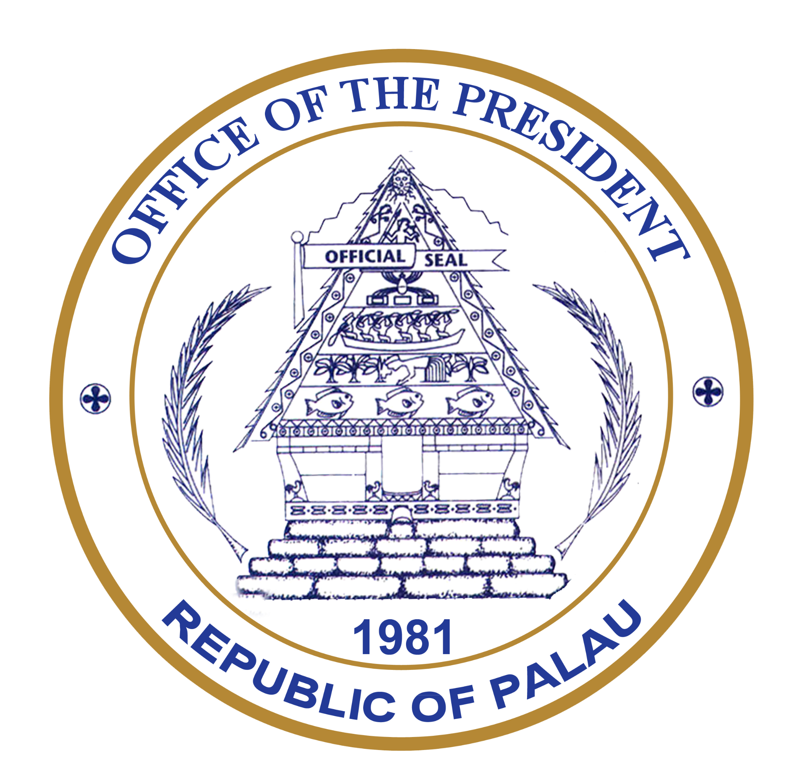
Official Address to the International Seabed Authority General Assembly
H.E. Surangel S. Whipps Jr., President of the Republic of Palau
ISA General Assembly, Kingston, Jamaica
July 27, 2026
Mr President,
Allow me to congratulate you on your election and assure you of Palau’s full support as you guide the work of this Assembly. I also thank Ambassador Gardiner for his leadership during the 30th session.
I also thank the Secretary-General for her report and for her leadership during one of the most consequential periods in the history of this Authority. We are grateful for your commitment to strengthening this institution and ensuring that every Member State is heard.
To the Government and people of Jamaica, thank you for your generous hospitality. It is a privilege to return to the birthplace of UNCLOS and to the home of this Authority.
Excellencies, colleagues, and friends:
Two years ago, I warned this Assembly of a new form of colonialism emerging in our ocean.
Last year, I spoke of a line in the seabed – a moment when humanity had to decide whether the deep ocean would be governed by guardianship or by corporate greed.
Today, that line has become a test:
A test of whether we still believe in multilateralism.
A test of whether international law can withstand political and commercial pressure.
A test of whether science will genuinely guide our decisions.
And ultimately, a test of whether the common heritage of humankind truly belongs to all humankind.
This debate has never been only about deep-seabed mining. It is about whether the rules that bind nations together still matter, especially when they become inconvenient.
For a small island developing nation and Big Ocean State like Palau, that question is existential.
Without respect for, and adherence to, international law, we have no voice equal to larger powers. Without multilateralism, there is no common heritage. Without UNCLOS, there is no certainty that future generations will inherit an ocean governed by law, rather than wealth and power.
That is why I have travelled more than 13,000 kilometres to be here. Palau will continue to defend this institution, even when we challenge decisions before it. Defending multilateralism does not mean remaining silent when it is tested. It means having the courage to strengthen it.
I also return because many whose future depends on the decisions taken in this room have no seat at this table: Pacific Island children; Indigenous peoples; coastal fishers; future generations; and the countless ocean species that cannot speak for themselves.
We have a solemn responsibility to govern not only for ourselves, but for all of them.
In Palauan culture, inheritance is not measured by financial wealth. It is measured by the health of the land and ocean we leave behind. We do not own them. We hold them in trust.
A generation that leaves behind more than it inherited has honoured its ancestors. A generation that leaves less has failed its descendants. That understanding has guided Palau for millennia. It explains why we have consistently chosen stewardship over exploitation and long-term responsibility over short-term gain.
For me, it is also deeply personal.
Earlier this year, my father passed away. To the people of Palau, he was a respected leader, a High Chief, and a servant of our nation. To me, he was simply my father and my first teacher.
When I was a boy, he taught me to swim through strong currents and to fish in deep water. At the time, I thought he was teaching me practical skills. Only later did I understand that he was teaching me something much greater: "Do not panic when the current turns against you. Know what you stand for. And have the courage to keep swimming, even when others are carried in another direction."

Those lessons have guided me throughout my life.
When I was eight years old, during the energy crisis of the 1970s, international interests proposed building one of the world’s largest petroleum storage facilities on Palau’s fragile reefs. The project promised jobs, investment, and economic transformation.
Many believed it was an opportunity too great to refuse. My father did not. Nor did High Chief Ibedul and the courageous Palauans of the Save Palau Movement. They were not opposed to development. They simply understood that some things, once lost, can never be recovered.
As a fisherman and a dive guide, my father understood those reefs better than any consultant’s report ever could. He knew they were not simply beautiful places. They were our food security, our culture, our economy, our identity, and our inheritance. Together, these leaders asked a question that remains just as relevant today: before asking what we might gain, we should first ask what we might lose.
High Chief Ibedul captured that wisdom perfectly when he said: "The risks to our traditional, cultural, and social way of life are not worth the short-term economic benefit."

The superport was never built. History proved them right. Because they had the courage to say "not yet," my generation inherited healthy reefs, thriving fisheries, and one of the richest and most biodiverse marine environments on Earth.
Their greatest gift to us was not money. It was choice. They left us with options because they refused to sacrifice tomorrow for today.
Today, this Assembly faces a remarkably similar choice.
Will we allow short-term commercial interests to outweigh our responsibility to future generations? Or will we recognise that sometimes the greatest act of leadership is restraint?
For Palau, the answer has never changed. When the consequences may be irreversible, we must choose precaution. It is the foundation of good governance.
That is the principle upon which this Authority was founded. UNCLOS did not establish the International Seabed Authority to promote exploitation at any cost. UNCLOS entrusted Member States with the collective responsibility to organise and control activities in the Area on behalf of humankind.
Those words matter.
Not on behalf of those with the greatest technology or deepest pockets. Not on behalf of those who arrived first. Not on behalf of shareholders or markets. On behalf of humankind.
Today, that responsibility is being tested. Around the world we see growing pressure to bypass multilateral institutions whenever they are considered too cautious or too slow. Palau rejects that approach completely. The answer to pressure on multilateralism is not to weaken it. It is to strengthen it.
Palau therefore remains deeply concerned by attempts to undertake unilateral mining activities in the Area. As the Secretary-General has made clear, such actions would be inconsistent with international law. Every Member State represented in this chamber has a responsibility to uphold UNCLOS within these walls, and beyond them.
Recent developments also raise important questions about the relationship between rights and knowledge acquired through the UNCLOS system and activities pursued outside it. Scientific knowledge and commercial opportunities developed under the common heritage regime cannot be separated from the responsibilities that accompany them. Where legitimate questions of contractual compliance arise, this Authority must be able to examine them thoroughly.
Accountability and due process are not competing principles. Both are essential to the credibility of this institution.
Excellencies, this debate has changed because the world has changed.
When UNCLOS entered into force, our understanding of the deep ocean was extremely limited. Today we know it is the largest living space on Earth – regulating our climate, storing carbon, supporting marine food webs, and sustaining biodiversity on a scale we are only beginning to understand.
Yet it is also one of the least understood ecosystems on our planet. Every major scientific assessment points to the same conclusion: the more we discover, the more we realise how much remains unknown.
At the same time, our ocean is already under unprecedented pressure from climate change, pollution, overfishing, and biodiversity loss. Before asking it to carry yet another industrial burden, the case for its necessity must be clear.
We are often told that deep-seabed mining is essential for the energy transition, economic security, or strategic competition. Yet respected scientists, economists, and policy experts continue to challenge that assumption, pointing instead to innovation, recycling, circular economies, and better stewardship of the minerals already extracted.
If alternatives remain available, why would we choose the path that carries the greatest uncertainty and the greatest risk of irreversible harm? The burden of proof must rest with those who seek to change the status quo.
Equally important is the question of equity. The common heritage of humankind was never intended to privatise profits while environmental and economic risks are borne by the ocean, developing countries, and future generations. Nor should it become another arena for geopolitical competition.
UNCLOS promises equitable benefit-sharing for all humankind, particularly developing States. But if environmental risks are externalised, if public revenues decline elsewhere, and if uncertainty remains over commercial viability, the promise of equitable benefit-sharing remains unproven.
Some costs cannot be measured on a balance sheet. The value of a healthy deep ocean and its role in regulating our planet cannot simply be reduced to dollars and cents. Those costs do not disappear because we fail to count them. They are simply passed to future generations.
And that is risk-sharing for the many, and profit for the few.
If the science remains incomplete, the economics unproven, and the governance unfinished, then the obvious question remains: Why the rush?
We also have a responsibility to uphold every part of UNCLOS, including Article 154, which requires this Assembly to undertake a periodic review of the international regime of the Area. That review is long overdue. Independent scrutiny strengthens institutions—it does not weaken them.
Trust must also be matched by accountability. Before exploitation is ever contemplated, this Authority must possess:
Robust inspection mechanisms; effective compliance systems; and genuine transparency.
At four kilometres beneath the ocean’s surface, oversight cannot depend on trust alone.
Compensation can never become permission to harm or destroy what cannot be restored. No financial mechanism can recreate an ecosystem that has evolved over millions of years. Prevention must always come before remediation.
There is another reason this Authority must continue to evolve. When UNCLOS was negotiated, the BBNJ Agreement did not exist. Today it does. These institutions have different mandates, but they govern one ocean. Sediment plumes do not stop at contract boundaries. Migratory species do not recognise legal jurisdictions.
Nature is deeply connected. Our governance must be deeply connected too. As the first country to ratify the BBNJ Agreement, Palau strongly supports closer cooperation between these institutions to ensure our international obligations reinforce one another.
For Palau, however, this conversation is about more than science, economics, or law. It is about culture. It is about identity. It is about our relationship with the ocean itself.
We do not simply live beside the ocean. We live with it. We pray with it. We eat from it. Our stories travel through it. Our ancestors remain connected to it. What some see as an empty seabed, Pacific peoples recognise as a sacred space.
That is why Indigenous knowledge belongs alongside science in informing the decisions of this Authority.
We therefore support the establishment of a Roster of Experts on Cultural Matters, bringing together Indigenous knowledge holders, cultural heritage experts, and representatives of the world’s Indigenous sociocultural regions. If we are to govern humanity’s common heritage wisely, then those who have safeguarded it for thousands of years deserve a permanent place in our deliberations.
Excellencies,
Today, 43 States support a moratorium, precautionary pause, or ban on deep-seabed mining. When Palau first called for a moratorium in Lisbon in 2022, few imagined that coalition would grow so quickly. Today, support reaches across regions and oceans, from the Pacific to Europe, Africa and the Americas.
We may use different language, but we are united by one conviction: industrial exploitation should not proceed while science remains inadequate, governance incomplete, and the common heritage exposed to unacceptable risk.
A precautionary pause is not an absence of leadership. It is leadership. It recognises that where uncertainty is profound and consequences may be irreversible, wisdom demands patience.
To those Member States that have not yet taken a position, I extend an open invitation: engage with us. This debate belongs to all of humanity because the largest living space on Earth belongs to all humanity.
One day our children, and their children, will ask what we knew. We will have to tell them that we knew these ecosystems were ancient. That recovery, where possible at all, could take centuries or longer. That the science was incomplete. That the economics were unproven. That alternatives existed.
And then they will ask us one simple question: What did you do?
I hope we will be able to answer that we defended international law when it was tested. We defended multilateralism when it came under pressure. We respected science when certainty could not yet be claimed. We listened to Indigenous knowledge alongside modern science; and We remembered that the common heritage of humankind could never belong to our generation alone.

Let Jamaica, the birthplace of UNCLOS and the home of this Authority, be remembered not as the place where the common heritage of humankind was divided by haste, but where humanity found the wisdom to protect it.
When history asked us to choose between artificial urgency and stewardship, we chose stewardship.
That will be our legacy. That will be the inheritance we leave behind.
Kom kmal mesulang. Thank you very much.

