INTERNATIONAL SEABED AUTHORITY

Journal
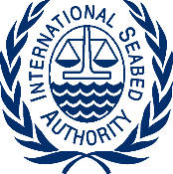 Journal No. 11/Rev

INTERNATIONAL SEABED AUTHORITY
Thirtieth session
Kingston, Jamaica
7-18 July 2025

Monday, 7 July 2025

10:00 AM – 1:00 PM COUNCIL
(333rd Meeting)
The Kenneth Rattray Conference Room

3:00 PM – 6:00 PM COUNCIL
(Informal Meeting)
The Kenneth Rattray Conference Room

