Additional Profit Share: An Alternative Equalisation Measure

Background
The African Group and other commentators have raised concerns about whether it is reasonable to assume that contractors will pay 25% corporate income tax (CIT) to their sponsoring states, or in practice, a much lower rate or no tax at all. The Africa Group has proposed an additional fixed-rate royalty to address this issue.
The benefit of using an additional fixed-rate royalty is that it should be relatively easy for the ISA to administer. The amount due would be a function of nodule prices multiplied by volume sold—the same information required to administer any mineral royalty.
However, there are also challenges in relying on an additional fixed-rate royalty:
- Under a scenario of low mineral prices and/or very high costs, profits would be lower, which would result in lower CIT payments, leaving contractors with less CIT to credit against the additional royalty. As a result, the contractors would end up paying an additional royalty to the ISA over and beyond their CIT payments to the sponsoring state, even if they are paying a full 25% CIT rate. If this happens in unfavourable market conditions, it could put a strain on investors’ cash flows. This risks undermining the entire investment proposition in DSM, and may generate calls for renegotiation by the time the additional royalty is supposed to apply.
- Under a scenario of high mineral prices and/or low costs, profits would be higher, which would result in higher CIT payments, leaving the contractor with enough CIT to credit against the additional royalty, even if its CIT rate is much lower than 25%. As a result, the additional royalty would not be fulfilling its role as an equalization measure.
An alternative equalization measure would be to adopt an additional profit share in place of the additional royalty.
An additional profit share would take the form of a cash-flow tax, which belongs to the broader category of resource rent taxes. A resource rent tax can take many forms, such as a profit-sharing contract. There is an abundant literature on the economics of such fiscal instruments, in particular from economists affiliated with the International Monetary Fund. Many countries have adopted some version of a resource rent tax, in particular in the oil and gas sector, with varying degrees of success (e.g., Angola, Australia, Cook Islands, Ghana, Guinea, Liberia, Malawi, Namibia, PNG, Sierra Leone, Timor Leste). One reason some countries have abandoned resource rent taxes is that these taxes are back loaded, i.e., they generate revenue late in the life of a project. Countries tend to expect revenue earlier on from their extractive resources, as they rely on them for budget spending and public investments. But that characteristic makes a cash flow tax a good instrument as an equalization measure for the ISA. The ISA will already be receiving revenue from royalties from the start of production, which should be its main source of funding. And taking effect late in the life of a project will give contractors an opportunity to first pay CIT in their sponsoring states, even when they benefit from accelerated depreciation or Research and Development tax incentives, so that they have CIT credits to offset against the additional profit share.
This proposed additional profit share is explained below.

Additional Profit Share Explained
Contractors would pay the ISA an additional profit share from which they could deduct the CIT (and potentially other taxes) paid to the sponsoring state in the previous year along with any amount of CIT paid to the sponsoring state in previous years and not yet credited against the profit share (i.e., unlimited carry forwards of CIT credits).
The additional profit share would be based on the contractor’s pre-tax cash flow, which differs from the definition of income or profit under international accounting standards or various countries’ tax rules. The most important elements are the following:
- Any cost incurred during exploration, development or production is expensed in full as negative cash flow when incurred. This includes capital expenditure i.e., there is no depreciation. There is no capitalization, amortization, or provisions either.
- Sales and other types of revenues are included as positive cash flow only when they are realized.
- The cost of capital is approximated by applying an uplift on negative cashflows every year, as long as cash flows are negative. Therefore, such a profit share would be designed like a resource rent tax. This design implies that interest expense is not a deductible cost. This structure is common in the oil and gas sector and has the additional benefit of lowering the administrative burden of auditing financing costs.
It is assumed that the additional profit share will only apply to contractors’ extraction or collection business in the Area. Therefore the extraction or collection business will be ring-fenced from other activities downstream, such as processing, when calculating pre-tax cashflows, and only CIT (and potentially other taxes) paid on extraction-related profits would be creditable against the profit share.
Step-by-step explanation of the additional profit share as an equalization measure
- Defining the collector’s pre-tax cashflow
Revenue :
- Realized revenue from nodule sales
- Revenue from selling any piece of equipment previously included as cost
- Any other revenue from a company’s mineral extraction business in the Area.
Less Collector costs:
- Operating costs
- Capital expenditure
- Capex Maintenance cost
- Site Restoration Cost
- Exploration & Exploitation fees to ISA
- Royalty to ISA (Option 4)

- Calculating the collector’s cumulative pre-tax cashflow
 | Collector pre-tax cashflow | Uplift on negative cashflows | Cumulative pre-tax cashflow
Year 1 | CF1 = Collector pre-tax cashflow in year 1 (see Step 1) | N/A | CCF1 = Cumulative pre-tax cashflow in year 1 = CF1
Year 2 | CF2 = Collector pre-tax cashflow in year 2 (see Step 1) | U1 = Cumulative pre-tax cashflow in year 1 multiplied by X% if CCF1 < 0, otherwise U1 = 0 | CCF2 = Cumulative pre-tax cashflow in year 2 = CCF1 + U1 + CF2
Year n | CFn = Collector pre-tax cashflow in year n (see Step 1) | Un-1 = Cumulative pre-tax cashflow in year n-1 multiplied by X% if CCFn-1 < 0, otherwise Un-1 = 0 | CCFn = Cumulative pre-tax cashflow in year n = CCFn-1 + Un-1 + CFn
- Calculating the gross profit share
Year n:
If CCFn < 0, there is no profit share owed to the ISA. Otherwise:
If CCFn >=0, the profit share applies to the smallest number of CFn or CCFn: Min (CFn , CCFn)
The gross profit share is then equal to: PFn = Min (CFn , CCFn) x X%
- Calculating tax credits
Any CIT (and other covered taxes) paid to the sponsoring state is included as a creditable amount against the additional profit share.
Assuming year n is the first year that cumulative pre tax cash flows are positive.
During years 1 to n, CIT (and other covered taxes) accumulate. CIT1 is CIT paid in year 1, etc.
Cumulated CIT credits in year n = CCITn = CIT1 + CIT2 + … + CITn-1
- Computing the net profit share
The net profit share owed to the ISA is the gross profit share calculated as in Step 3, minus any CIT (and other covered taxes) paid to the sponsoring state in previous years (Step 4), and not yet credited against a profit share in previous years.
Starting in year n, the cumulated CIT credits are credited against the ISA’s additional profit share.
Cumulated CIT credits in year n+1 = CCITn+1 = CCITn + CITn – PFn
Cumulated CIT credits in year n+2 = CCITn+2 = CCITn+1 + CITn+1 – PFn+1
If CCIT is positive, no cash flow tax is paid to the ISA. If CCIT is negative, then that amount must be paid to the ISA.
Important parameters of the additional profit share as an equalization measure
An additional profit share requires specific rules that follow the step-by-step explanation above, and three important parameters: the rate of uplift on negative cash flows, the rate of the profit share itself, and a list of payments that could be used as credits against the profit share, along with corporate income tax payments.
These parameters should be determined based on an updated version of the financial model for deep sea mining, and an agreed range of average effective tax rates.
There is a case for setting the profit share at a rate of 25%, as this is the corporate income tax rate that was initially assumed in the MIT model. A profit share rate of 25% combined with a price varying royalty could result in an effective tax rate for deep-seabed mining within the range of land-based mining tax regimes for the same or similar minerals. If the Open-Ended Working Group on the payment regime for deep sea mining wishes to start from a rate of 25% for the additional profit share, further economic modelling work should be undertaken to finalise the royalty rates that when combined with a 25% additional profit share result in an acceptable effective tax rate.

Illustrations:
First scenario: application of an additional profit-share when a contractor is paying 25% CIT on its income derived from extraction / collection business:
Collector cashflows in real terms (i.e. net of inflation), over a 40-year deep-seabed mining project
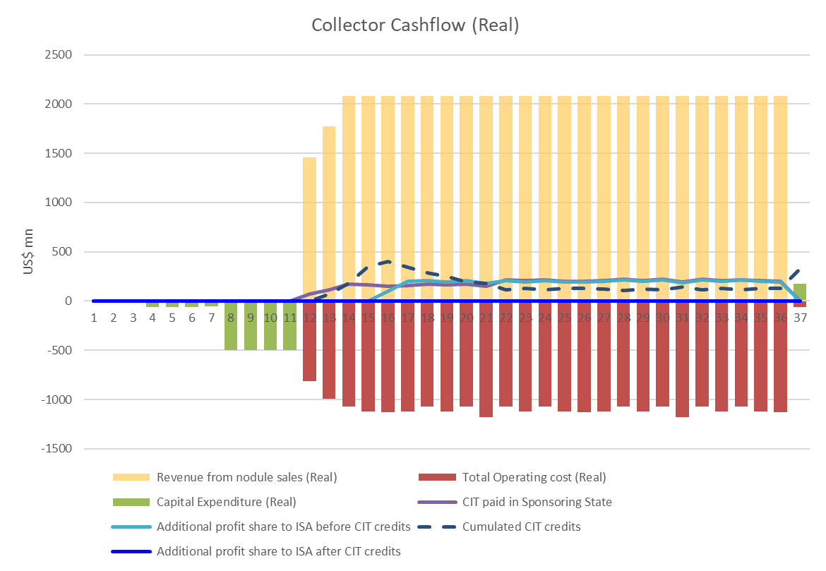
Collector cashflows in real terms (i.e. net of inflation), over a 40-year deep-seabed mining project – CIT and additional profit share only
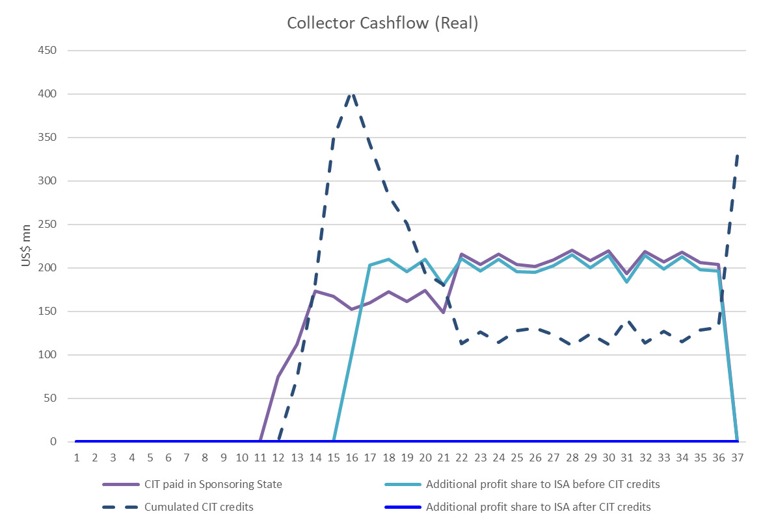
Source: IGF deep sea mining model
Second scenario: application of an additional profit-share when a contractor is paying 0% CIT on its income derived from extraction / collection business:
Collector cashflows in real terms (i.e. net of inflation), over a 40-year deep-seabed mining project
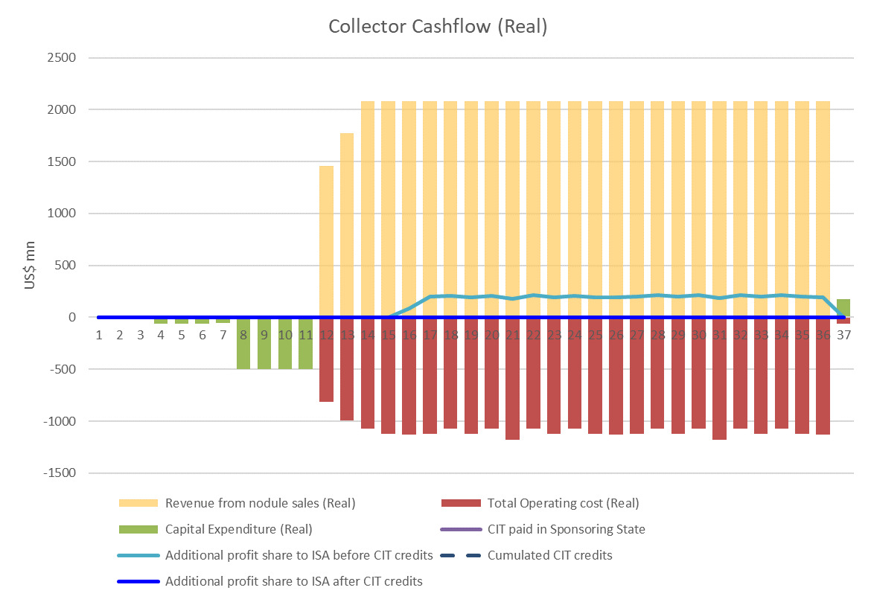
Collector cashflows in real terms (i.e. net of inflation), over a 40-year deep-seabed mining project – CIT and additional profit share only
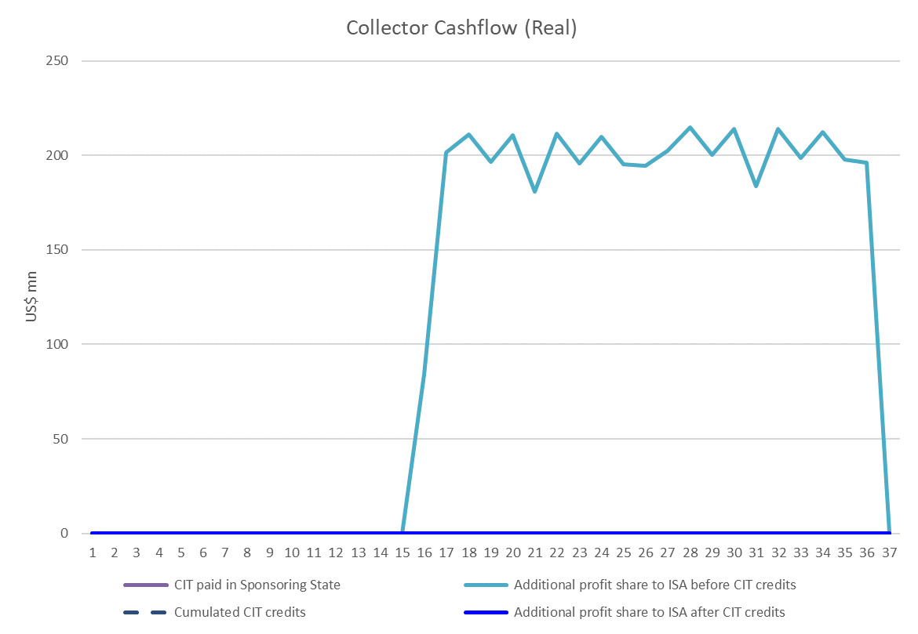
Source: IGF deep sea mining model

For a recent example, see - Baunsgaard, T. & Devlin, D. (2021). Resource-rich developing countries and international tax reforms. In R. A. de Mooij et al. (Eds.), Corporate Income Taxes under Pressure: Why Reform Is Needed and How It Could Be Designed. International Monetary Fund. https://www.elibrary.imf.org/display/book/9781513511771/ch015.xml
Daniel, P., Keen, M., & McPherson, C. (Eds.). (2010). The Taxation of Petroleum and Minerals: Principles, Problems and Practice (1st ed.). Routledge. https://doi.org/10.4324/9780203851081

